LinkedIn Profile Checklist Alumni Connectors
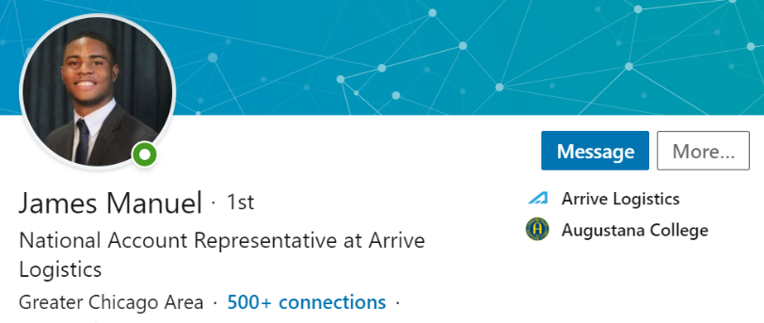
- PHOTO: Dress appropriately and intentionally for your LinkedIn photo

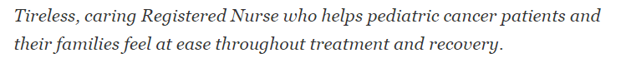
- HEADLINE: Tell people what you are excited about now and the cool things you want to do in the future.

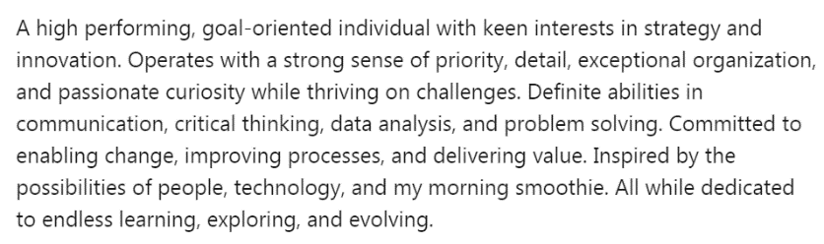
- SUMMARY: Describe what motivated you, what you are skilled at, and what is next.

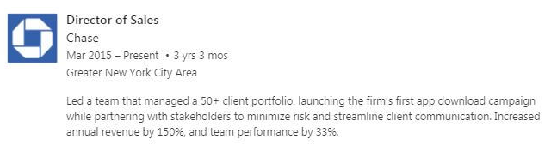
- EXPERIENCE: Unlike a resume, your LinkedIn work experience entries should be general, less detailed, and not tailored for a certain position.
Want more LinkedIn tips? Check out https://students.linkedin.com/

Your LinkedIn experience descriptions should start with a written summary of your achievements specific to each role. Bullet points are great for a
resume because they contain a lot more information
without huge blocks of text. However, paragraph form
is acceptable on LinkedIn because you won’t be including
a ton of information.

Augustana College | Career Development Office | First Floor, Olin Center | 309-794-7339 | careerdevelopment@augustana.edu

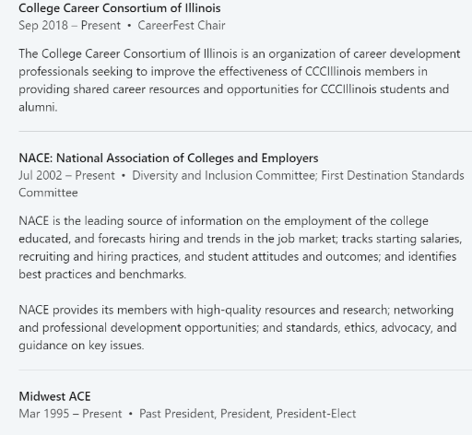
- ORGANIZATIONS: The Organizations section of your LinkedIn profile is the place to record the real-world associations and clubs to which you belong. Listing professional membership organizations on your profile proves you are an integral force within your community and an involved member within your industry.

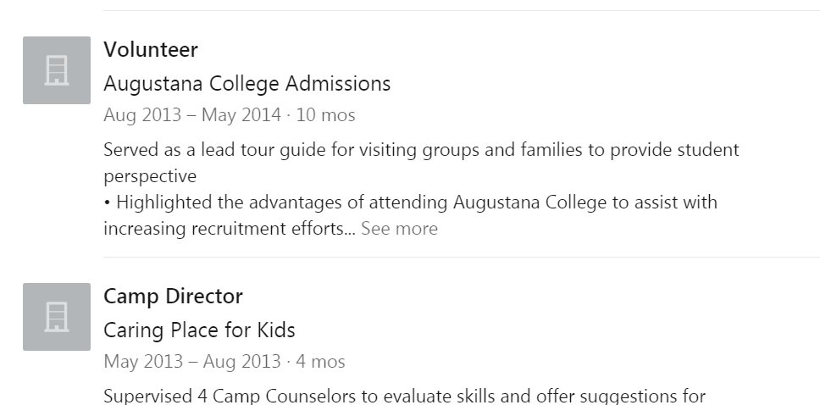
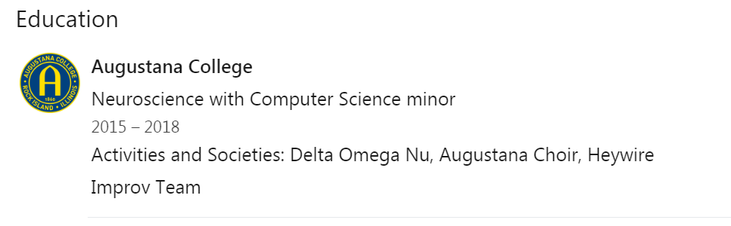
- EDUCATION: Starting with college, list all the educational experiences you have had including summer programs and study away.
- VOLUNTEER EXPERIENCE: Even if you were not paid for a job, be sure to list it. Employers often see volunteer experience as just as valuable as paid.

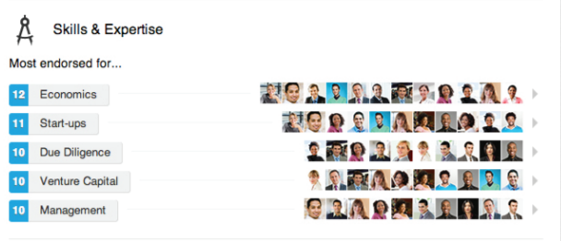
- SKILLS & EXPERIENCE: Add at least five key skills- and then your connections can endorse you for the things you are best at.

- HONORS & AWARDS: If you earned a prize in or out of college, don’t be shy! Let the world know about it.
- PROJECTS: Whether you led a team assignment in school or built an app on your own, write about what you did and how you did it.

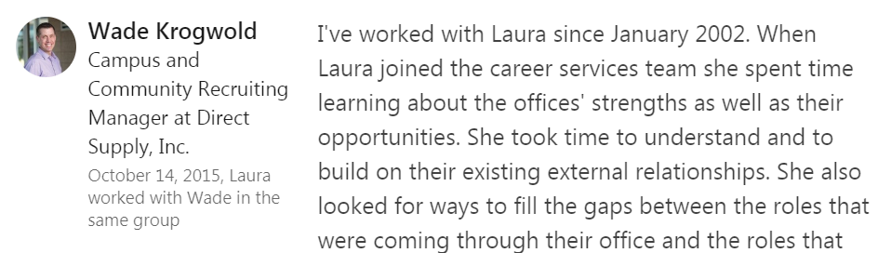
- RECOMMENDATIONS: Ask managers, clients, and peers who have worked with you closely to write a recommendation. This gives extra credibility to your strengths and skills.
Augustana College | Career Development Office | First Floor, Olin Center | 309-794-7339 | careerdevelopment@augustana.edu

