-Phi Omega Phi’s Buckets for Benefits- Team Sign-Up

Team’s Name: __________________________
(Or Captain’s Last Name)
-*Team Members’ Information-
-Please indicate shirt size if interested ($12/shirt)
Player 1(Captain)(S/M/L/XL/2XL)

Name: ________________ Age: _____ Gender: M/F

Phone #: _________________
E-Mail (optional): _____________________

Player 2 (S/M/L/XL/2XL)

Name: ________________ Age: _____ Gender: M/F

Player 3 (S/M/L/XL/2XL)

Name: ________________ Age: _____ Gender: M/F

Player 4 (optional)(S/M/L/XL/2XL)

Name: ________________ Age: _____ Gender: M/F

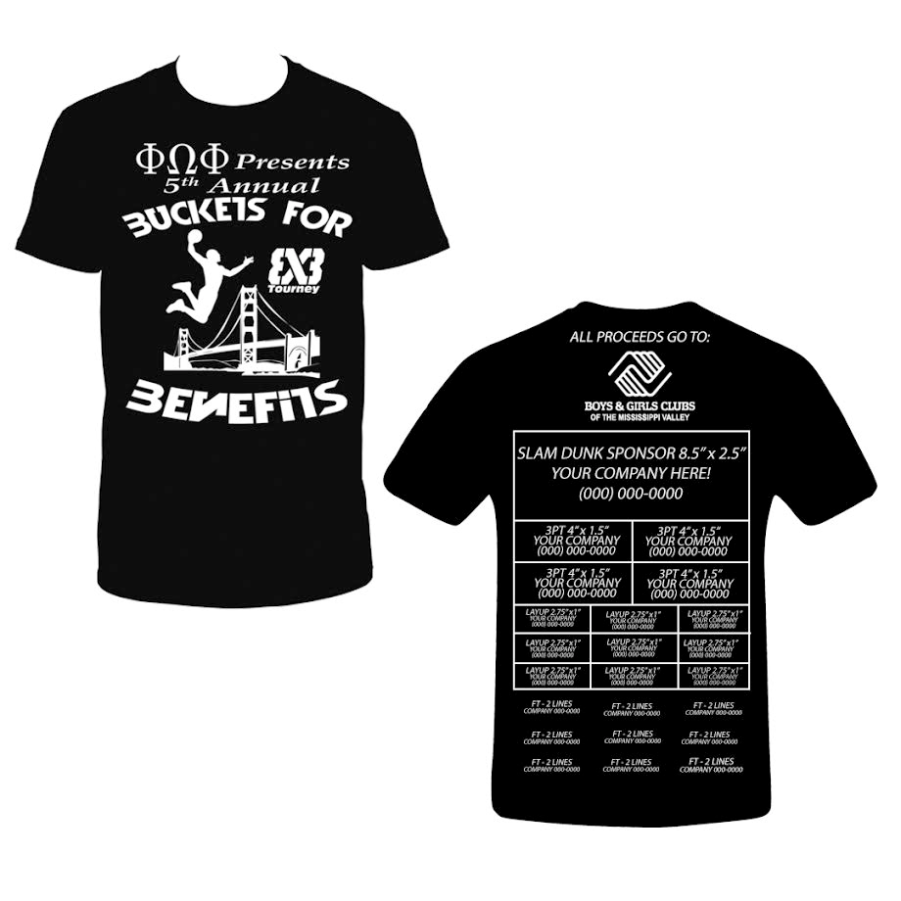

Due by 5:00pm on March 22nd
Place this form and your team’s $35.00 (Check's/Money Order's Payable to 'Buckets for Benefits') in an envelope when complete. Augustana Students may turn this in to Ryan Hicks, John Vaccaro, or the front desk of the OSL Office. Off-campus participants may turn it in to your school front desk.

Questions? Contact:
Bucketsforbenefits@gmail.com

