Faculty Position Request
July 2022
Please use this form to request any type of faculty position (tenure and non-tenure track). Submit requests to the Provost at academicaffairs@augustana.edu. Tenure-track requests are due by June 1st, and contingent faculty requests are considered on a rolling basis.
Department _____________________ Date ______________________
- Information on requested position
- Position Type (tenure-track, professional faculty, continuing lecturer, visiting, fellow, adjunct, part-time) ____________________
- Discipline & Specialty ______________________
- Brief overview of needs of the position. Please include specific courses that you expect this new faculty member to teach and any other duties needed.
- What are the three most pressing needs to be filled by this position? (e.g, curricular need-specialization, student demand, accreditation requirements, etc.)
- Is this request the result of a retirement, resignation, or previous failed search? If so, please explain.

- How is this faculty line request consistent with the forward-looking strategic direction of your department and the larger field (e.g., most recent departmental review recommendations, recommendations of your disciplinary/professional associations, skills needed by graduates, interdisciplinary connections)? More specifically, how does this request respond to and anticipate the changing needs of our students (both during and after their time at Augustana), future directions in your discipline, and evolving needs of our world?

- Any additional rationale for this position?

Departmental Data
Please provide the following information from APS. Log into the platform at reports.eabanalytics.com and navigate to the Program Analytics dashboard.
(More APS resources can be found in the APS Resources Shared Drive folder)
Data for the first set of items below can be found in the APS Program Analytics Dashboard → Department/Program Review tab then filtering for your Department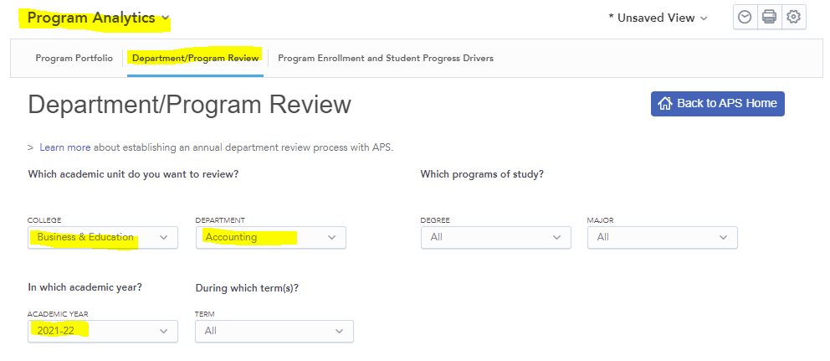
Enrollment in Courses Offered by Department
APS Program Analytics dashboard → Department/Program Review tab → Enrollment in Courses Offered by Department heading
 | 2019-20 | 2020-21 | 2021-22
Total Attempted Student Credit Hours (SCH)
% of Attempted SCH Taught to Own Majors
% of Attempted SCH Taught to Service Majors
Comments/explanation (optional):

Enrollment in Programs of Study (Majors)
APS Program Analytics dashboard → Department/Program Review tab → Enrollment in Programs of Study heading
 | 2019-20  Headcount | 2020-21  Headcount | 2021-22  Headcount | 3-Yr Trend in Program Enrollment | 3-Yr Trend in Program Enrollment - College Comparison
Program/Major I Name
Program/Major II Name
(if applicable)
Comments/explanation (optional):

Data for the next set of items are found in the APS Department & College Analytics dashboard → Department Overview tab → filtering for current academic year; term: Fall, J-term, and Spring; your department; and course type.
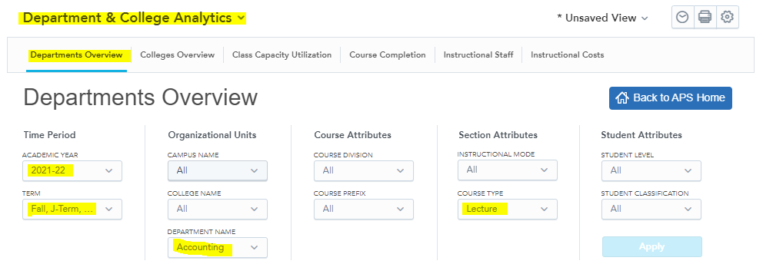
Section Size & Capacity Utilization
APS Department & College Analytics Dashboard → Departments Overview Tab → Section Size and Capacity Utilization Headings. Be sure to filter for lecture or lab courses as applicable to your department.
 | 2019-20 | 2020-21 | 2021-22
Median Section Size (lecture course type)
(from Trends in Section Size graph)
Median Section Fill Rate (lecture course type)
(from Trends in Section Fill Rate graph)
Median Section Size (lab course type if applicable)
(from Trends in Section Size graph)
Median Section Fill Rate (lab course type if applicable)
(from Trends in Section Fill Rate graph)
Comments/explanation (optional):
Faculty Composition
APS Department & College Analytics Dashboard → Departments Overview Tab → Trends in Instructional Staff Headcount. Include all Course Types for this section.
 | 2019-20 | 2020-21 | 2021-22
Tenured/Tenure-Track Faculty
Prof Faculty/Cont Lect
Visiting Faculty/Fellow
Adjunct/Part-time
Total
Comments/explanation (optional):

Program Enrollment (Minors)
This is the only data for this request form not found in APS.
To locate this information, please log into Arches. Under the My Reports and Links section, select DEPARTMENT_CHAIRS_MENU and then the Minor Counts report. Within the report, use the Total numbers in the last column on the right. Please note this report is based on the Fall Day 10 numbers.
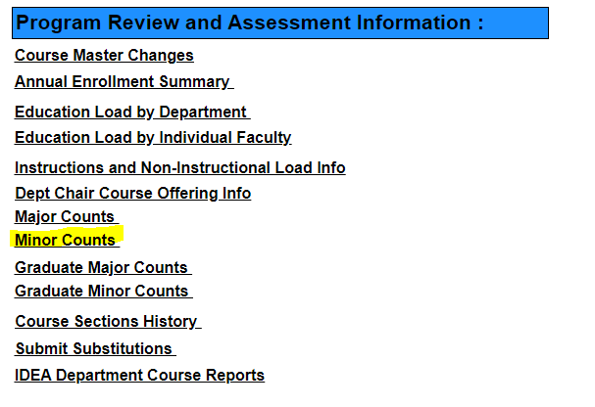
Minor Name: | 2019-20 | 2020-21 | 2021-22
Headcount
Please add additional lines/charts if you have multiple minors in your department
Comments/explanation (optional):

For tenure-track requests only, please suggest names of tenured faculty members outside your department who may serve as an outside member on the search committee if search is approved.
___________________________________________________
___________________________________________________
___________________________________________________

