HPBX Training Manual for the Yealink T54W Desk Phone
Phone Number and Extension:
VM PIN:
CommPortal Password:
Admin / End User (circle one):
These are the online account management sites aka the CommPortal (which we will discuss and reference in the training). You will only need two of the CommPortal Links (Based on Location). If you are having trouble accessing the CommPortal sites, let us know and we will help you with logging in. The last two sites are for our additional online resources, which we encourage everyone to use.
https://commportal.jagcom.net (MN West End User/General VM/Auto Attendant)
https://commportal.jagcom.net/bg/ (MN West Admin User)
https://vm.mymetronet.net/surround.html#login.html (End User/General VM/Auto Attendant)
https://vm.mymetronet.net/bg/surround.html#bg/login.html (Admin User)
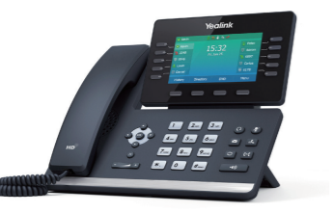
https://business.metronetinc.com/wp-content/uploads/2020/12/User-Guide-CommPortal- Business-Voice-9.25.2020.pdf (CommPortal All User Guide)
https://business.metronetinc.com/business-voice/metronet-business-phone-technologies/ (Online Training Material and Tutorials from Metronet)
Please keep this guide as a quick reference tool and as a place to jot down important information in the spaces provided.
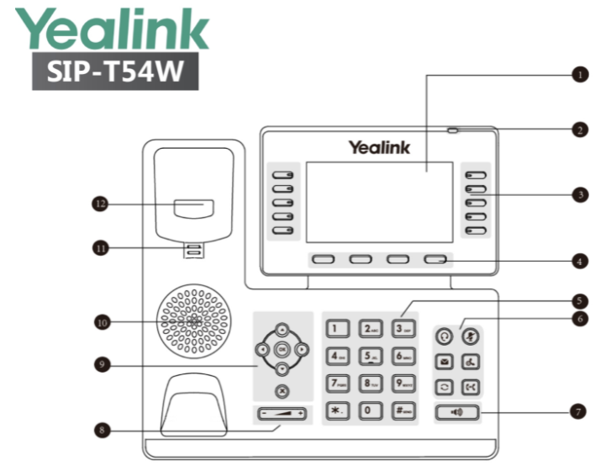
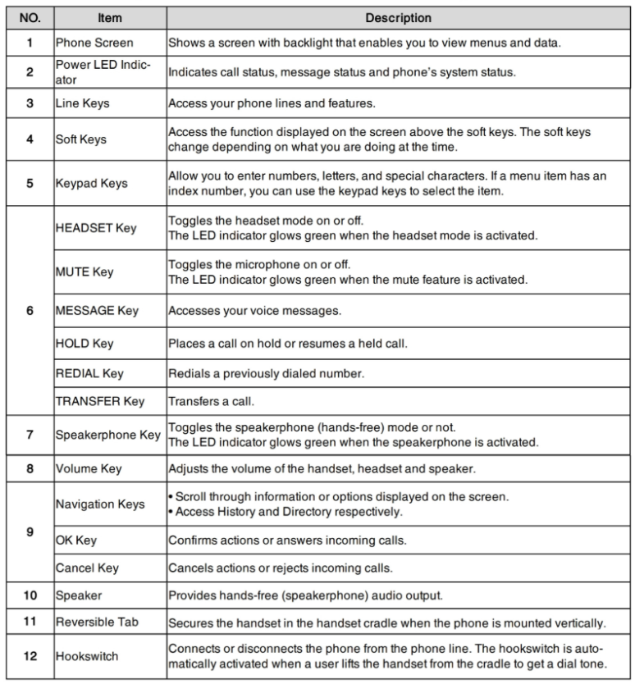
Section I: A Brief Introduction to Your Phone

Welcome to the HPBX (Hosted Private Branch Exchange System) Phone system and your new Yealink T54W Desk Phone. The Yealink T54W has a variety of features that will help you manage your new phone system with ease. Pictured above is the basic layout of the phone. The ten physical “line keys” are found on either side of the LCD screen and the four “soft keys” are under it. These keys can be programmed with different functions such as:
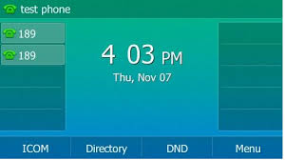
Line Keys
- Enhanced Monitored Extensions
- Enhanced Call Parking
- Group Pickup
- Transfers
- Speed Dials/Short Codes
- (It is important to note Line Keys 1 and 2 are USUALLY pre-configured for you to have 2 appearances of your OWN NUMBER. Overwriting them can cause malfunctions where you might not receive calls at all or make it more complicated for you to have more than one call at a time. You can verify this on the Customer CommPortal by going to LINE KEYS and clicking on Key 1 and Key 2. If you see “Line 1” in the boxes, it is set up for 2 appearances and should NOT be changed without first checking with a system administrator or Metronet.)
- The Yealink T54W has a total of 27 programmable Line keys (including Keys 1 and 2). If there are more keys programmed than the available spots, the last key will show “More”, allowing you to see the next set of key options.
Soft Keys
- History
- Directory
- DND (Do Not Disturb)
- Menu
- (It is important to note, these key labels listed are just a few examples of what you might see on the Idle screen. Not every phone configuration will show the same default keys, and other keys can be managed in the CommPortal. The Soft Keys will also change and display different functions based on how you are using the phone at that time, as seen in the picture.)
LCD Screens
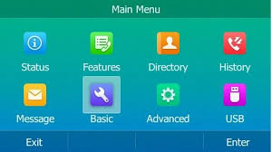
In addition to the Idle screen, which shows the line and soft keys, pressing the Menu soft key will take you to the Main Menu, which shows all the shortcut options you can scroll through.
- Status
- Features
- Directory
- History
- Message
- Basic
- Advanced
- USB
- (It is important to note, that not EVERY phone configuration is always going to look the same as the illustration. Some features may have been disabled by Metronet, your system administrator or may not be available in your market.)
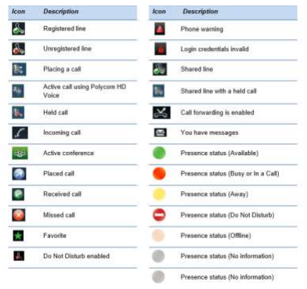
The Status Bar
At the top of the phone is a thin bar which will show different icons that indicate certain things on the phone. The phone status (i.e. DND), mute/silent, missed calls, voicemails, the mode of making or receiving the calls (speakerphone or headset) and the transfer status will all have a different icon.

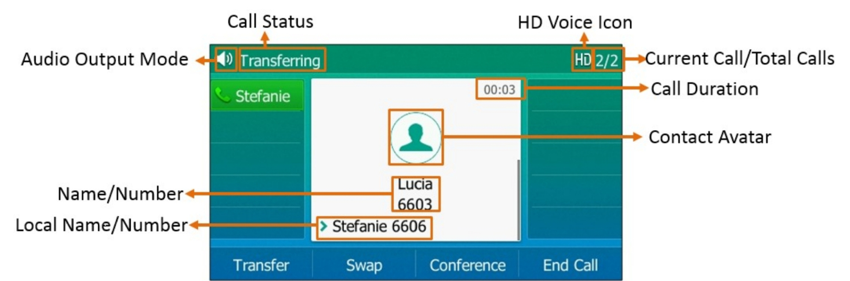
Answering Calls
All the calls whether incoming or outgoing will show as a text box on the LCD screen with contact information. When answering a call, you can do one of the following:
- Pick up the receiver to use it. (Mode 1)
- For speakerphone, press the speaker key. (Mode 2)
- If you have a headset (Mode 3) you would like to use, press the headset button. The Yealink T54W will support wired or wireless headsets if they are compatible and set up correctly. If you are not sure if your headset of choice is compatible or not, ask your System Administrator or a Metronet representative to see a full list.
- You will see the calls highlighted in different colors, indicating their status. You can use the up/down arrows to check all call statuses.
- If you are already in a specific mode, (Headset, Speaker phone or the default receiver) the phone will automatically use it for every call, unless you change it. If you are on an active call and get a second call, you will get a call waiting tone (which is a low beep) and you will see the “incoming call” screen pop up again on the display. You can swap back and forth between calls or even put them into a 3-way call. You can also decline, transfer, or mute the call.
- (It is important to note, only one call can be active at a time. So, when swapping between calls, remember to put the caller on HOLD before choosing the other line. If you do not, the first call will drop when you pick up the second.)
Placing a Call
On the Yealink T54W, placing a new call can be done from a couple of different places on the phone. You can start by pressing the number on the dial pad. The phone will try to autofill the information as you type it if it is a number in your call history or is listed as a contact. You can press the Call History or Directory soft keys on the Idle screen or the Main Menu icons, which will allow you to select specific numbers or contacts to call. If you have speed dials or extensions programmed on to the idle screen’s line keys, you can also press those to call out. You can also redial a call. Press the History soft key and choose the entry you would like to call back. If you are calling the last person in the history, press the history button twice.
Section II: Phone Features
As mentioned in the introduction, the phone has many different functions that can programmed to your specifications.
- Enhanced Monitored Extensions- These are extensions that will show you if a person is on an active call or not. If they are, there will be a small, red LED light next to their name. If they are not on a call, the indicator will stay dark. Having a monitored extension is helpful in situations like if you can see that a person is using their phone but has a new call needing to be transferred to them, the enhanced extension would allow you to tell the second caller that they are busy and will send them to their voicemail. These extensions are programmable Line Keys which can be configured in the CommPortal.

- Enhanced Call Parking- This feature allows a person to place an active call into an “orbit” or system wide hold, which can then be picked up from any other phone in the business group that has the feature on it. We can program up to three call park orbits per phone in the CommPortal on the Line Keys. If someone is not by their desk, but a call comes in for them, the call can be parked and then picked up wherever that person is that has a phone nearby. So, instead of only having the option of sending it to their phone via their direct extension, which could mean the call will go to voicemail if they cannot get to it in time or forcing that person to go back to their office to pick up the call, the call can go to the system wide hold and be resumed. The Call Parks will be set on the idle screen, and like the monitored extension, the indicator will blink red when the call orbit is in use.

- Group and Directed Pickups- Having Groups, Group Pick-ups and Directed Pick-ups are another convenience feature that helps further direct calls to the appropriate people or departments. There are several different types of groups that can be configured: -Hunt Groups- Makes a group of phones all ring together on an incoming call. -Paging Groups- Will set off an audible alarm, followed by an announcement on speakerphone to certain people in the business group. -Departments- Groups certain phones or users together to allow for them to all be called together or set up so that their group never misses a call, even if the call is going to a different user in the group.
If you have been added to a specific group by your system administrator, a Group Pick-Up will allow you to pick up another phone you hear ringing in your group. To use the feature, when you hear another phone ringing in your group, press the Pick-Up Key, if one has been programmed, or dial *11 to connect a call. If you are not a part of a group, but hear another extension ringing, you could still use a Directed Pick-up to grab the call. To use the feature, when you hear another phone ringing that is not in your group, press the Directed Pick-Up key or dial *12. Then enter the extension to the phone you wish to pick up.

- Call Transfers- Transferring Calls is another helpful and easy to use feature on the phone. Transfers can be done to anyone and do not have to stay within your business group, unless it is to an extension. You have the option to choose between two different types of transfers: Cold/Blind/ Unattended transfers or Warm/Consultative/Attended transfers. Your system is set to use warm transfer by default. You can initiate a cold transfer by pressing the Phone-to-Phone Key (Transfer Key) one time or the Transfer soft key on an active call, and entering the phone number or extension, and then pressing the transfer key again. Blind transfer sends the calling party’s caller id. A warm transfer is done by waiting to press the Transfer key a second time until after the recipient answers which will allow you to announce the call to them. Press the Cancel soft key at any point prior to completing a transfer to return to the original call. You can also program what is called a “One Touch Call Transfer” on your phone’s Line Keys, which allows the user to perform an Unattended (Blind/Cold) Call Transfer to a person without all the extra keystrokes. The key on the phone will be configured to transfer the call to only one number. One way to use this feature would be the user could configure a key on the phone to automatically transfer calls to their mobile phone. If you would like to transfer a call directly to someone’s Voicemail, while on an active call, press one of the Transfer keys and the caller will automatically be placed on hold. Enter 7 followed by the user’s extension. Press the Transfer key again. This completes the transfer to voicemail.

- Speed Dials and Short Codes- Again, nothing too new here. Speed Dials can be configured in the CommPortal much like the Call Parks or Monitored Extensions. A speed dial is not required to be a part of your business group to be set up. So, if you want to have your favorite restaurant on speed dial or your best work friend’s cell phone number, those can be programmed in the same way. Short Codes are much less common these days, because they can only be configured at the group level and cannot be changed from the preset configuration. More short codes can be added to individual phones if they do not try to replace the pre-existing group codes. To set up speed dials for frequently called numbers, navigate to the Main Menu, and select Features. The Speed Dial function is designated as "DSSKEY". When you open the DSSKEY, it will give you a list of lines (2-9) which you can select and assign certain functions to by changing the Type. Fill in the blank spaces with the Account ID (This is the line number and it must match the line key number (Line key 2 is Line 2, Line key 3 is Line 3, and so on). The label identifies how the speed dial will appear on the phone, and the value will be either a phone number or extension.
Once all this information is filled out, push the Save Soft Key.

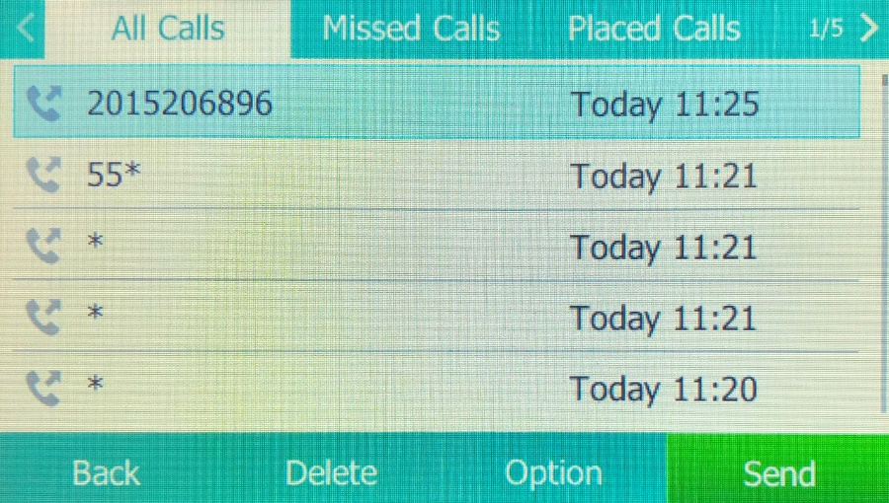
- Call History: All Calls, Received Calls, Dialed Calls, Missed Calls, Placed Calls and Redial- If you miss a call or need to call a person back, the VVX411 has a few different call lists you can look at to pull recent calls from. If you choose the Redial Soft Key, it will pull the last number and call it. If you want to redial from a different menu, see your recent call logs or clear these lists of recent and missed calls, you can use the directional pad to get the different lists. Simply press one of the arrows on the circle pad, which will take you into your call lists. You can see the options for the different call lists including: Favorites, All Calls, Missed Calls and Dialed Calls. The option to choose a contact or number out of these lists to redial is just one option. You can also add a new contact, block numbers, add favorites, delete single call list entries, and clear the call lists completely by pressing the “More” option and then “Clear” and the phone will ask which list you wish to clear out. To access your “Favorites” press the up arrow. For your “Placed Calls”, press the right arrow. To see your “Missed Calls”, press the down arrow. Lastly, for your list of “Received Calls”, press the left arrow. These lists are also accessible from the “Directories” shortcut on the LCD and then choosing Recent Calls. If you need to see older call logs that might no longer be available to view on the phone anymore, you can access them on the CommPortal by selecting Call Logs and then setting the date range you wish to see.

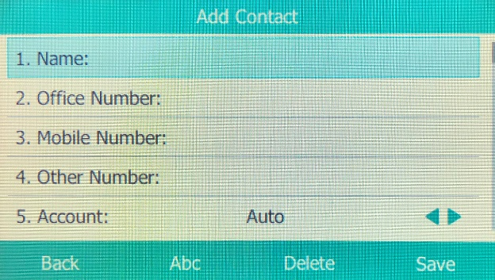
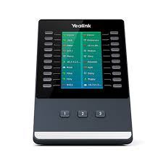
- Contact Directory- To access your Contact Directory, press the directory icon on the Main Menu. By default, all the contacts from your business group will be preloaded into the phone for your convenience, but additional contacts and sub-directories such as Favorites or Blocked can also be created and managed. To add a new contact from the Call History, navigate to the call you want to add and press the Option Soft Key then select Add. Edit any information that you need to change, and press Save. Once the contact is in the directory, you will be able to add the number as a Favorite or Block it if you ever needed to. If your Business Group has more contacts, speed dials or extensions than available spots on the desk phone, we also have a device called a Side Car, which can hold up to an additional 80+ extensions. The T54W can support up to three connected side cars.

- Paging/Intercom- The Paging/Intercom system is, by default, only going to transmit to the phones of other users on site. Paging is a one-way communication preceded by a warning tone and then the announcement, but the receiving party cannot reply. On the CommPortal, you can create Paging Groups, so you can reach to certain departments or people without it going to the entire company. The T54W phones have Paging Group 1 already configured in the system to page the entire company. If your press the Page Soft Key, you will see a list of all the configured groups. Use the arrow pad to scroll and press the Page soft key again. Once you hear the tone, begin speaking. When you are done, end the call. If a page is sent, the receiving party does not have the option to decline it. If they are on an active call, they will receive it once they hang up. Intercom dialing is slightly different from paging. This two-way communication gives off the tone, like a page, but the recipient can reply to the person or group sending it. These announcement systems are used primarily for quick interruptions, questions or to relay time sensitive information. As with paging, intercom dialing within the group will automatically come up on speakerphone. You can change modes to handset or headset after it is received. On the phone, the Intercom function is a shortcut on the Main Menu. Paging is set up as a Soft Key on the idle screen. We also offer loudspeaker systems that can be installed in buildings with their own numbers and extensions, called Algo speakers. These would have their own phone numbers and extensions so specific ones can be reached. If you need to add these, please ask your salesperson about getting them on your account. If you have an existing system already set up, we are normally able to connect them as well.

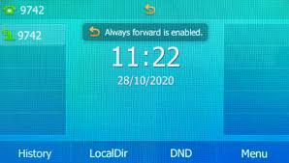
- Call Forwarding- If you want your desk phone calls to handle incoming calls differently than normal, you have a few choices. By utilizing Call Forwarding, you can send calls directly to alternate numbers. Setup of Call Forwarding can be done by using the *Star Codes, on the home page of the end user CommPortal, the Forward screen icon on the main menu (also in Settings >>> Features) or by reaching out to Metronet. There are two different call-forwarding options; one being unconditional call forwarding which means the desk phone will never ring and the call will immediately transfer to the alternate number. Do Not Disturb is a type of unconditional forwarding. The other type is conditional call forwarding, and like the name suggests, forwards the calls when certain conditions have been met. Voicemail is a type of conditional call forwarding and is obviously the default for most phones, but other conditions such as: Busy or No Answer are also available. You can view and change these options on the user CommPortal home screen. Call forwarding can also be disabled altogether and after the phone stops ringing, the line would just drop. *Star Codes can also be used for call forwarding functions and can set this up or disable them. Once call forwarding has been set up, it will always use the last saved number as the default, unless changed by the user.

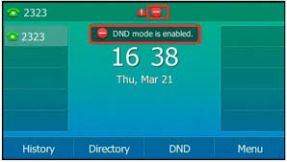
- DND (Do Not Disturb) - Do Not Disturb is like the cell phone feature “Airplane Mode”, but for the desk phone. Your phone will not ring when this is on and will automatically go to wherever you have designated to send it, again most commonly to voicemail. You can use the on screen DND shortcut or soft key to quickly turn it on or off. When it is enabled, you will see a red circle with a white line in it on the shortcut, next to your line appearances and in the status bar.

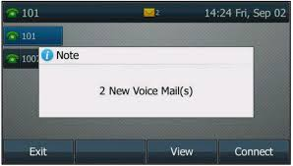
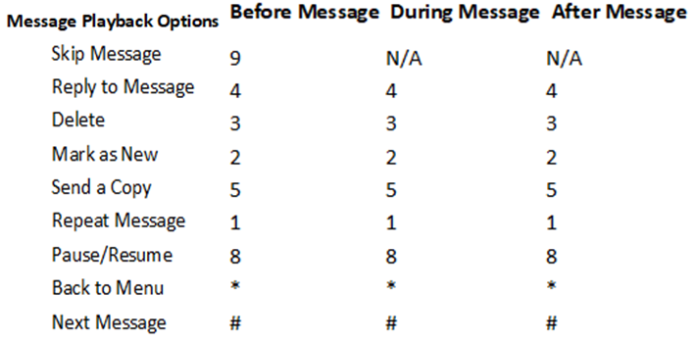
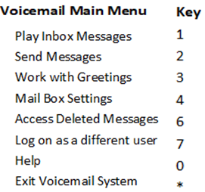
- Message (Voicemail) - Another customizable phone feature is your voicemail. The voicemail icon can be found on the LCD screen as Messages and on the left side of the keypad. To use the system, you must set up your profile. Otherwise, users should be able to leave messages, but you won’t be able to check them or clear the alerts. Pressing *98 (*318 for MN West customers) will have you complete your profile over the phone, but it can also be done on the CommPortal or by pressing either of the Messages keys. You can set your profile to have a custom PIN, emailed transcripts of voicemails and multiple personalized greetings. The Voicemail can also be disabled so there is no personal profile at all. If the system were set up this way, it would ring the phone and immediately drop after your ring time expired. You have several greeting options to choose from like a default system message, your name or number with the default message, or your own recording. When setting your PIN (if you want one), choose a unique six-digit PIN to authorize your mailbox and follow the prompts. The PIN can be disabled in the CommPortal, so the messages play without having to enter anything. Sometimes businesses may want to have a “general voicemail” that picks up the main line for the company. Users in the business group can have this general voicemail programmed into the Line Keys. The amount of space/time available for messages on your voicemail will depend on the product tier the business group has. Whenever there is a new message waiting in the inbox, you will see a red, flashing light on the upper right-hand side of the phone and an envelope will appear on the status bar and a number will be on top of the messages icon on the LCD showing new messages. It is important to remember, if you do have two mailboxes, they both need to be checked to clear the “message waiting” icons. The CommPortal site has additional voicemail features that cannot be accessed from the handset or the *Star Codes. Like a Visual Voicemail feature on cell phones, on the website you can see all the messages listed and select specific messages to play, fast forward, rewind, pause or call back or forward. You can also delete specific messages or even all messages. The email notifications can be sent to you on multiple emails. Premium Users can get transcribed copies of their personal voicemail messages emailed to them as well. The Transcription service is not available for General Voicemails. The voicemail can also be checked from an outside line, like a cell phone. Call the number of the desk phone and let it ring to voicemail and press the star key and enter your six-digit pin to identify your mailbox. To manage the voicemail when you call in to the system, you will need to follow the prompts and use the keypad to do specific functions.

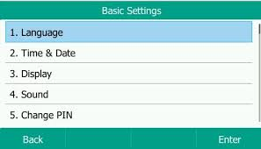
- Settings- After going into the Settings shortcut from the Main Menu, you will see four options: Basic, Advanced, Features and Status. In the Basic settings, we can control more “physical settings” of the phone. Options like software updates and configurations, adjusting volume, ringtones, power off/reset, date/time format, time zone, screen brightness and screen time out can be found here. The Advanced settings option requires a PIN to access it. Metronet does NOT have that PIN information, as it is a Yealink setting. Features has the options for many of the items already covered in the session like Redial (Last Call Return), DND, Call Forwarding and Paging. The Status tab will give you options to see more details of the software settings and diagnostic options for the phone. Most of the time, these are preconfigured settings and should not be adjusted unless first consulting with your system administrator or Metronet.
Section III: Additional HPBX Phone Features
HPBX phone systems do have some additional features that may be new to you; we will discuss a few of them in this section.
- Star Codes- Another, albeit less commonly used, feature the Polycom supports are “*Star Codes” which were mentioned earlier. They are used less primarily because most of these functions have already been pre-programmed into the phone as shortcuts or soft keys, so there is no need for them. However, some users are more familiar with these and prefer them. *Star Codes share many similarities to speed dialing and extensions. *Star Codes are a way for you to quickly hit a couple of keys and have your phone perform different functions, such as pressing *98 (*318 for MN West users) to directly dial to your personal voicemail as opposed to dialing the full number or the shortcuts are disabled. As mentioned earlier, things like Call Forwarding, Parking options, and Paging can also be used to work with the *Star Codes. There are quite a few of them, and the full list of codes and their functions will be attached.

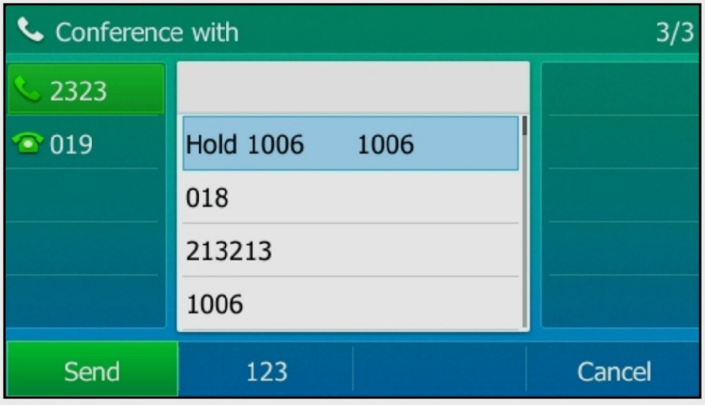
- Multi-Party Conference Calling/3-Way Calling- Conference Calling or 3-Way calling is another feature available on VVX 411 phones. To do a 3-way call from the phone the person originating the call must add each user individually. You would initiate a call with one person and then put them on hold and then call your second user and press Conference to join the calls. By default, the maximum number of lines that can participate is 3 (including you), but it can be increased if requested. If your business needs to be able to conference with larger parties, it might be time to consider adding a feature called a “Conference Bridge”. The feature includes a phone number and 2 PIN numbers. One PIN is used by the call administrator to set up the virtual conference room. The other is a participant PIN, used by everyone else to join the call. Each bridge also includes a set number of “spaces” for the maximum number of participants and a monthly allowance of free minutes to use when people to login to the call. The administrator on 3-way and conference calls, can manage the specific users and can mute or remove people (split the user) from the call if needed. For more information on availability and pricing on this feature, ask your salesperson.

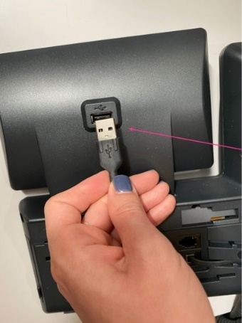
- Record Calls- The Yealink T54W has a USB port on the back of the phone, behind the LCD screen that can be used for external local storage of recorded calls (as well as headsets and side cars). Up to four hours of recordings can be saved in one .wav file. When a USB flash drive is attached to the phone, the USB icon displays in the status bar with a message indicating how much recording time is available. During an Active call, select the More Key, then Record and then Start. An “R” displays on the USB icon to indicate recording is in progress. To end recording, select Stop or Back and then End Call. If you need to set a break in the recording with a pause, Pause, and Resume to resume. To play recordings, navigate to Settings, Features, Removable Storage Media, Browse Recordings. Select a file, Open, and then Play. Recordings can also be deleted from the same screen. Please remember to always give the person being recorded, the chance to decline.

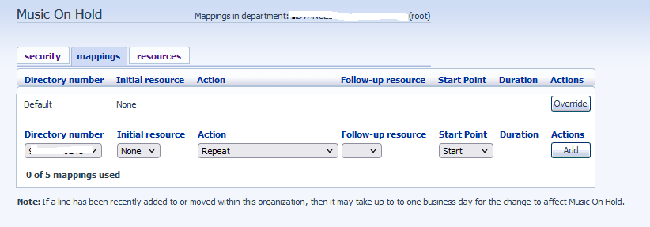
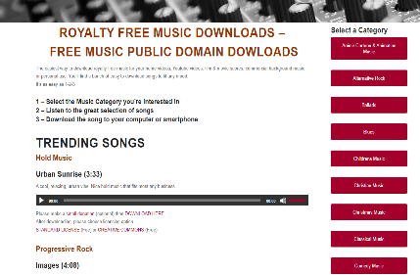
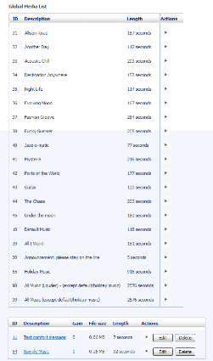
- Music On Hold- The HPBX system allows you to set Music on Hold for your customers to hear instead of just dead air. This free service can be set up with the preset music choices provided to you in the Commportal System on your Admin Portal. However, if you have songs that you have paid to license, are your own compositions or music that is “royalty free” or in the public domain. Since, public domain music is material to which no exclusive intellectual property rights apply, these files are free to download and easy to add to your system. Copyright material that you do not own or have permission to use would need to be changed. You can have a different type of music on hold for each individual line on the account, or one that will apply to the entire business group. Once you go into the portal and select the number, your “initial resource” field will be the song you want to pay when a customer is placed on hold from that number. If you would like to have recorded announcements interrupt the song, that is also an option under the actions, and selecting either the “initial” or “follow-up” interruptions. You can then tell the system if you want to resume the music, either at a random point in the song, or at the beginning, and then hit “Add” to save the selection for that number. If you ever need to modify any of these music or announcement settings, you will see an “Edit” button will appear once it has been saved. There is a limited amount of space available to save the files (usually its 25MB) and (usually) has a cap of 5 different resources you can use to pull music from.
Section III: CommPortal
While many of the features we have discussed can be controlled directly from the phone, you and your Network Administrators have even more access via the Customer CommPortal. Through the course of this training session, we have discussed the CommPortal several times. This tool is one of the most powerful phone management features that you, as customers, have access to. There are two versions of this site: one for End Users and one for Administrators. End Users have limited access but can control many individual functions like voicemail and password resets, call forwarding and key management on the phones. Administrators accessing the portal have more “group level” functions such as modifying hunt groups, changing extension numbers, reassigning physical phones, changing auto attendant settings (with the exception of audio), changing a user’s name and setting up music on hold. The side by side illustrations are of the two different dashboard home screens. To manage all functions of the Time of Day, General Voicemail or Auto Attendant numbers, login to them via the End User Portal. After any changes are made in the portals, remember to reboot your phone to see the changes immediately, or wait for the phone to auto update the new configuration settings overnight. The picture that is below the two dashboards is the Key Manager home screen. There are a lot of programmable options seen here, so if you have trouble setting things up on your own to look or act exactly how you want, reach out to an administrator or Metronet representative.
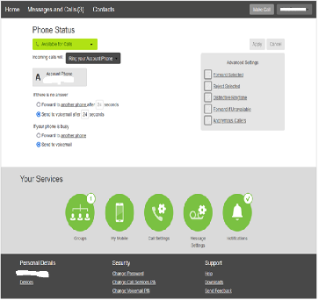
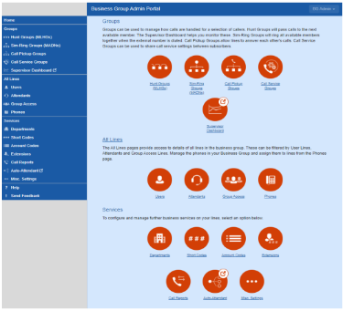

Business Administrator Portal Homepage End User Portal Homepage

HPBX phone systems may look complicated at first, but once you start to work with the phones a bit more, hopefully it will all become very easy to remember. I hope you enjoy the phones and found this presentation helpful. I am adding my contact info at the bottom if you have additional questions. Thank You!!
Project Management/HPBX Trainer Info: Matt Hotz matt.hotz@metronetinc.com 812.316.0826
For additional support and resources, please visit us at: http://metronetinc.com/hpbx or https://business.metronetinc.com/business-voice/metronet-business-phone-technologies/
For live tech support, please contact the MetroNet Business Tech Support Center at 833.393.6857
For questions regarding pricing, promotions, or billing, please contact the MetroNet Business Customer Support Center at 855.769.0936

