Augustana Emerging Professionals Spring 2023 Internship Application

Augustana College has received grant funds from the Illinois Board of Higher Education (IBHE) to support underrepresented students participating in unpaid internships with partner nonprofit organizations. The purpose of this program is to provide more opportunities for underrepresented students to have professional experiences related to their field of study. Grant funds will be used to pay students an hourly wage (currently $13/hour) for these internships. A list of partner organizations and available internships can be found on the next page. More information about each internship can be found at: https://careers.augustana.edu/blog/2022/10/17/emerging-professionals-internship-program/ OR scan the QR Code below.
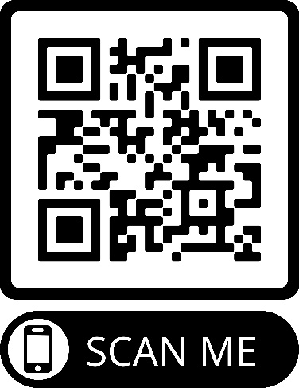
Qualifications for the Emerging Professionals Program:
- Permanent resident of the state of Illinois
- At least a sophomore in standing at the time of application
- 2.5 GPA or higher
- Identify as a member of at least one underrepresented population:
  - Student of Color
  - Female, Non-binary, or Transgender
  - LGBTQIA+
  - Student with Disability(ies)
  - Adult Learner/Non-Traditional Aged Student
  - First Generation Student

To apply, complete this form and submit, along with an updated resume, to Bobbie Tidball at bobbietidball@augustana.edu by November 18, 2022. Internships will take place during the Spring 2023 semester. Students selected for an internship must provide proof of Illinois residency and register the internship for at least 0 credit.

Name: | Student ID:
Email | Phone:
Permanent Address:
G.P.A.: | Total Credits:

Which of these populations do you identify with (choose any that apply)? *This information will remain confidential and will be redacted from your final application materials. This information WILL NOT be given to hiring committees or potential/final employers.*

☐ Student of Color ☐ Female, Non-binary, or Transgender ☐ LGBTQIA+
☐ First Generation ☐ Student with Disability(ies) ☐ Adult Learner/Non-Traditional Aged Student

Which internships are you applying for? (You can apply for as many as you wish)

What makes you a good candidate for these positions? (Use additional pages if needed)

Spring 2023 Internships Available

City of East Moline
- Human Resources Intern

City of Moline (In Person)
- Environmental Sciences Intern
- Engineer Intern
- Communications Intern
- Community and Economic Development Intern

Closet2Closet (In Person)
- General Operations Intern

GiGi’s Playhouse
- Marketing Intern (Can Be Hybrid)
- Programs Intern (In Person)

Niabi Zoo (In Person)
- Animal Care Intern
- Conservation Education Intern

Quad City Botanical Center
- Education Intern (Can Be Hybrid)
- Horticulture Intern (In Person)

Rock Island County Public Health Department (In Person)
- Illinois Breast & Cervical Cancer Program Intern

The Arc of the Quad Cities (In Person)
- Human Resources Intern

World Relief Quad Cities
- Refugee Resettlement & Placement Intern (Could be hybrid)
- Refugee Employment Intern (In Person)

WQPT-PBS (In Person)
- Accounting Intern
- Education Outreach Intern

