Contents
I. General Guidelines 2
Policy & Globally Harmonized System (GHS) 2
Responsibilities 3
II. Hazard Determination 5
III. Labeling and Other Forms of Writing 6
Hazardous Materials Label Identification Chart 7 Container Labeling 8 Pictograms 9
Chemical Storage Areas/Unlabeled Pipes 10
IV. Training 10
Specific Chemical Hazards 11
V. Safety Data Sheets (SDS) 12
How to Read a Safety Data Sheet (SDS) 12
VI. Chemical Handling 20
Chemicals Used For Scientific Purposes/Chemical Delivery 20
Non-Routine Tasks and Spill Response 20
Outside Contractors…………………………………………………………20
VII. Appendices 21
Defining Health Hazards 21
Right-To-Know Turns and Definitions 23
Chemical Inventory List
- General Guidelines

Policy

Employees who use or may be exposed to potentially hazardous substances or harmful physical agents will be informed about the hazards of those substances or agents. These employees will be trained to prevent exposure and what to do if they are accidentally exposed. Employees will not engage in or be required to perform any task which is unsafe or unreasonably hazardous.

Hazardous substances, in some forms and concentrations, pose potential acute and chronic health hazards to exposed employees. Employees have the right to know this and how to protect themselves. Augustana College relies on the manufacturers and/or importers of chemicals for information, as described in the SDS and noted on container labels. The purpose of this program is to:

- Improve the detection, treatment, and prevention of occupational illness,
- Support the employee's right to know,
- Ensure that departments and workers can identify hazardous substances and hazardous situations, and
- Specify the training requirements associated with our Hazcom program.

This program applies to all departments that use, handle, or store hazardous substances when the presence of those substances can expose employees under normal conditions or in a foreseeable emergency. The following substances are NOT regulated under this program:

- Hazardous waste regulated by the Solid Waste Disposal Act
- Tobacco or tobacco products
- Wood or wood products
- Articles (manufactured products) such as pens, highlighters
- Food, drugs or cosmetics intended for personal consumption
- Products sold at retail which is incidentally sold to the College and/or employees, in the same form, approximate amount, concentration, and manner as it is sold to consumers.

Globally Harmonized System (GHS)

The Globally Harmonized System (GHS) is an international approach to hazard communication, providing agreed criteria for classification of chemical hazards, and a standardized approach to label elements and safety data sheets. It is based on major existing systems around the world, including OSHA's Hazard Communication Standard and the chemical classification and labeling systems of other US agencies. Augustana College shall rely on chemical manufacturers to comply with the GHS requirements and provide appropriate information pertaining to the hazards and precautions associated with their products.

Responsibilities

At a minimum, this program covers employees (including student employees, technicians, supervisors and researchers) who use chemicals in facilities maintenance, dining services, teaching, performance arts, research and clinical laboratories at Augustana College. It is also our policy that students, while not legally covered under this standard, will be given training commensurate with the level of hazard associated with their studies.

The Office of Human Resources/Safety is responsible for preparing and updating Augustana College's - Hazard Communication (Hazcom) Program, and for distributing it to departments who will implement the plan. The HR/Safety Office will also:

- Develop, implement and monitor the Hazard Communication Program
- Review the program annually for necessary changes
- Assist departments with employee training, consultation and documentation
- Maintain a chemical list of each hazardous chemical used/stored in the workplace. This list will include the chemical name, the chemical abstract service numbers (CAS) as applicable, and the departments where the chemical is normally used/stored.
- Maintain the chemical list for no less than thirty (30) years.
- Provide the chemical list upon request to the Rock Island Fire Dept.

The Department Chairs and Safety Officers will monitor the progress of the department toward achieving compliance. Each department that engages in the extensive use of hazardous chemicals will identify at least one Departmental Safety Officer to serve as a focal point for health and safety activities within the department. This person will:

- Work with the Department Chair and HR/Safety Office to assess risk
- Assist the Department Chair and Safety Manager in identifying, reviewing and approving non-routine operations, activities and procedures
- Assist the HR/Safety Office in developing and maintaining an inventory of hazardous substances used or stored within the department. The list will include the chemical name, the chemical abstract service numbers (CAS), where applicable, and the location where the chemical is normally used or stored. The information will be entered on the Augie SDS data base by the HR/Safety Office. The Chemistry Department will enter their inventory data directly.
- Notify the HR/Safety Office of chemicals added to or discontinued from the inventory.
- Request SDS on purchase orders by including "Safety Data Sheet requested" after the product name.
- Label containers of hazardous chemicals with the chemical name and appropriate hazard warnings, unless the existing label conveys the necessary information.
- Notify the HR/Safety Office when a new employee requires training.
- Inform students, contractors, sub-contractors, vendors, and visitors of any hazardous chemicals used in the areas being visited or areas where a person will be working.
- Coordinate disposal of Hazardous Materials with the HR/Safety Office.
- Report any large hazardous substance spills to the Security Department immediately for coordination of the cleanup procedures.
- Read the Program annually and notify the HR/Safety Office of any changes.

Each department is required to develop a training program for the benefit and protection of their employees. Training will explain the best way to handle hazardous chemicals and protect employees from hazards of chemicals.

The supervisors in each department where chemicals are used extensively will:

- Implement the Hazcom Program in their department,
- Schedule time for employees to attend designated training sessions,
- Assure that hazards of specific tasks have been identified and addressed before work begins,
- Obtain approval for non-routine operations, activities and/or procedures
- Enforce safe work practices, and
- Report hazardous conditions to the department safety officer.

Employee(s) will do the following in complying with the hazcom standard:

- Read Safety Data Sheets before using chemicals.
- Wear PPE as required by the SDS
- Assume that any mixture of hazardous chemicals is more toxic than the most toxic component.
- Seek information and advice about hazards from the SDS and staff, plan appropriate protective procedures, and plan positioning of equipment before beginning any new operation.
- Keep the work area clean and uncluttered, with chemicals and equipment properly labeled and stored.
- Clean up the work area on completion of an operation or at the end of each day.
- Be aware of unsafe conditions and see that they are corrected when detected.
- Dispose of hypodermic needles, lancets and broken glass in appropriate sharps containers, not in receptacles designed for routine trash.
- Notify supervisors and/or instructors if you believe you may have been over-exposed to a chemical.
- Wash areas of exposed skin thoroughly after working in areas with chemicals.
- Comply with workplace rules that PROHIBIT:
  - Consuming or storing food or drinks in areas where chemical contamination is possible
  - Using glassware or utensils typically used for chemical handling to store, serve, or consume food or beverages
  - Smoking, gum chewing, or applying cosmetics or lip balm in areas where chemicals are present
  - Wearing sandals or perforated shoes in areas where chemicals are being applied. Legs should be covered at all times in the laboratories.
  - Participating in practical jokes or other behavior that might confuse, startle, over-expose or distract another worker working with chemicals.
  - Using your mouth for pipette suctioning or to start a siphon.
  - Tasting or excessive inhalation of chemicals
  - Removing chemicals from the building
  - "Experimenting" or otherwise using or mixing chemicals or equipment for unauthorized purposes.

- Hazard Determination

Our chemical inventory is a list of hazardous chemicals known to be present in our workplace. The hazardous chemicals on the list can exist in a variety of physical forms including liquids, solids, gases, vapors, fumes, and mists. Sometimes hazardous chemicals can be identified using purchase orders. Identification of others requires a physical inventory of the department.

Chemicals are considered hazardous when they are:

- Regulated by OSHA in 29 CFR 1910.1200, as toxic and hazardous substances.
- Included in the American Conference of Governmental Industrial Hygienists (ACGIH) latest edition of "Threshold Limit Values for Chemical Substances and Physical Agents in the Work Environment".
- Found to be suspected or confirmed carcinogens by the National Toxicology Program in the latest edition of the "Annual Report on Carcinogens".
Augustana College, as a general operational goal, reduces the toxicity of chemicals whenever possible. Commonly used chemicals should have a hazard ranking of 2 or less, although certain chemicals in special operations (for example, our chemistry lab) may have chemicals with hazard rankings up to 4. When we purchase chemicals with high hazard rankings, we compensate for the level of risk by minimizing the volume to be purchased and controlling access to prevent unauthorized use.

- Labeling and Other Forms of Warning

Labels will at least identify the chemical name and provide appropriate hazard warnings. The chemical name may be a common name, trade name, or chemical name. The hazard warning is a brief statement of the hazardous effects of the chemical (i.e., "flammable," or "causes lung damage"). Labels frequently contain other information, such as precautionary measures (i.e., "do not use near open flame"). Our labels will be legible, though their sizes and colors can vary.

The department ordering and receiving materials will be responsible for labeling all the chemical containers in their possession. If the manufacturer label on the container has the necessary information (identity by name matched to SDS, hazards, and name and address of manufacturer), no other action is necessary. Employees will not remove or intentionally deface existing labels on incoming containers of hazardous substances. If the container is not properly labeled, it is the responsibility of the Department to provide it. Labels are not required if the portable container is intended only for immediate use by the employee who performs the transfer, and the contents of the container is entirely used during the employee's shift.

More than a decade ago, the National Paint and Coatings Association developed the
Hazardous Materials Identification System (HMIS) in order to quickly and easily convey health and safety information from paint manufacturers and suppliers to their customers. The HMIS system has gained wide acceptance in more than just the paint and coatings industry, and we typically use this system at Augustana College. Certain departments who often use flammable liquids may rely on the NFPA labeling system instead.

The HMIS ratings are for four categories: health, flammability, reactivity, and personal protective equipment (PPE). The first three categories are rated on a number scale from 0 to 4 (0 indicates minor hazard; 4 indicates severe hazard). PPE ratings are designated by a letter which corresponds to types of PPE that should be worn while using the product
Departments preparing labels for their containers may use at their discretion the following coding system to indicate hazards associated with the product to be labeled:

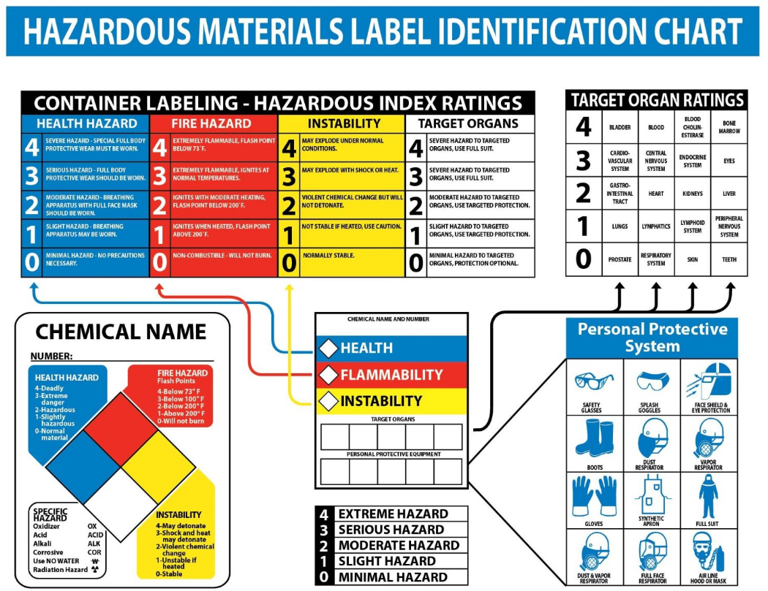

Health hazard (Blue), rated 0 - 4 as follows
0—Low hazard
1—Slight hazard
2—Hazardous
3—Extreme hazard or Potential carcinogen
4—Deadly or Human carcinogen

Flammability (Red), rated 0 - 4 as follows
0—Stable material, will not burn unless heated
1—Will ignite if preheated (Flash point (FP) at/or > 200° F or 93° C)
2—Will ignite if moderately heated (FP at/or > 100° F/38°C and below 200°F/93°C)
3—Will ignite if ambient conditions (FP < 73 F/23°C & Boiling Point > 100°F/38°C)
4—Burns readily at ambient conditions (FP < 730°F & Boiling Point < 100°F/380°C)

Reactivity (Yellow), rated 0 - 4 as follows
0—Stable and non-water reactive
1—Unstable if heated
2—Violent chemical change
3—Shock and heat may detonate
4—May detonate

Container Labeling

All chemical containers must be labeled. Labels shall not be defaced, remain legible and prominently displayed on the container, or readily available in the work area. The labels shall include the product identifier, signal word, hazard statement(s), pictogram(s), precautionary statement(s) and the name, address and telephone number of chemical manufacturer, importer or other responsible party. Manufacturer labels are acceptable if they contain this information. This information is necessary to cross-reference between the chemicals, the hazardous chemical lists, and the SDSs. If a chemical is transferred to a secondary container, the secondary container must be appropriately labeled. If an employee is transferring chemicals from a labeled container to a portable container that is intended for that employee's immediate use, no label is required on the portable container.

Pictograms

A pictogram is a symbol on a white back-ground with a red border that is intended to convey specific information about the hazards of a chemical. The pictograms which appear on the label are determined by the chemical’s hazard classification.
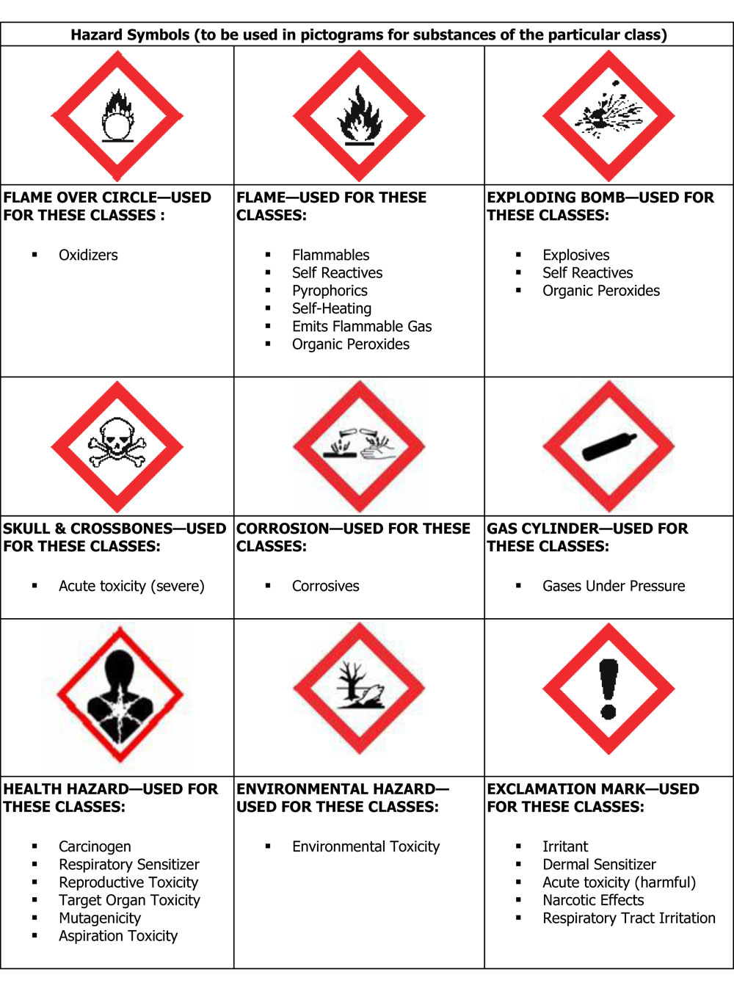
Chemical Storage

Any room that is primarily used for the storage of chemicals shall be labeled with the words "Chemical Storage." Any area that is specifically used for the storage of hazardous chemicals (i.e. shelving units) should be labeled in such a manner to ensure that all persons with access to that area will be aware that it is a chemical storage area. It is also encouraged that NFPA (National Fire Protection Agency) hazard warning diamonds be used where extremely hazardous chemicals are stored.

Hazardous Substances in Unlabeled Pipes

Supervisors must ensure that all pipes containing hazard materials (i.e. natural gas lines, waste lines) are labeled with the contents of the pipe. Employees are not to work on any unlabeled pipes until the contents of the pipe are determined and appropriate safety precautions have been determined for the work. Employees should notify their supervisors whenever their work involves disturbing unlabeled pipes.

- Training

The Department Safety Officer and/or Department Chair will train new employees as required by this Hazard Communication Plan. This orientation will:

- Explain what the SDS is, how to access them, and how to read them.
- Key hazards to which the employees are exposed through the chemicals most commonly used while doing their jobs,
- How to protect themselves from those hazards, and how to respond to problems including over exposure, injuries and/or spills.

"Employees" include student employees, student workers, 'volunteers' and contractors.
Training will be provided within 30 days of the employee's initial assignment, and whenever a new hazard is introduced into their work area.

The Department Safety Officer will coordinate training and maintain the department training records. In areas where the Safety Officer does not have sufficient resources or experience to provide this training, they will notify the HR/Safety Office that training is needed, and the HR/Safety Office will provide training and documentation. Training records will document:

- The training program outline
- Dates of training
- Proof of attendance
Hazcom training will discuss the following topics, and may be presented using a variety of media including video DVDs, classroom discussion, on-line training, practical training and handouts:

- The existence of the Hazard Communication Program
- Operations where hazardous substances are present
- Hazards typically associated with the department's tasks
- How to obtain an SDS for the chemicals in their work area
- How to read and interpret labels and the SDS
- The methods and observations that may be used to detect the presence or release of hazardous substance in the work area (such as monitoring, visual appearance or odor of hazardous substances when being released, etc.)
- The physical and health hazards of the substances in the work area.
- Measures they can take to protect themselves from hazards. These measures will include specific procedures the department has implemented to protect employees from exposure to hazardous substances, such as work practices, emergency procedures, and personal protective equipment.
- The employee's right to:
  - Receive information regarding hazardous substances to which they may be exposed.
  - Send information to their treating physician in the event of an exposure.
  - Exercise their rights to request information about hazardous chemicals in the work place without fear of dismissal or discrimination.

Information & Training on Specific Chemical Hazards

In addition to the initial training requirements detailed above, supervisors shall provide employees with information and training on the specific hazardous substances in their work areas. This training must be provided within 30 days of an employee’s initial assignment or reassignment, and whenever a new substance is introduced into the work area. This includes temporary employees and contractors.

This training and information will include:

- Identification/recognition of any departmental operation where hazardous substances are present
- Explanation of the purpose and contents of an SDS, interpretation of the hazard information contained within, and description of the location of the departmental SDS documents.
- Methods to detect the presence of hazardous substances in the workplace (alarms, odors, etc.)
- Methods to minimize exposure to hazardous substances in the workplace, including proper hygiene practices, personal protective equipment (PPE), and emergency procedures
- Specific hazard information covering non-routine work assignments as periodically performed by employees.

- Safety Data Sheets (SDS)

- The HR/Safety Office will compile and maintain a SDS master file in digital format.
- Departments are responsible for sending original SDS of new chemicals to the HR/Safety Office where the relevant data will be entered into the SDS database. If the Department desires to have paper copies on hand, they will be responsible for making those copies and keeping their reference file up to date.
- Department Safety Officers or Department Chairs will arrange for an inventory of their chemicals as requested by the HR/Safety Office
- The Biology, Chemistry and Physics department are responsible for recording their chemical inventory information into the Augustana SDS Database.
- SDS of discontinued chemicals will be sent to the HR/Safety Office, noting the date of discontinued use. These will be kept by the College for at least 30 years from the date the chemical was discontinued at the College.
- Employees will contact the HR/Safety Office if an SDS is not provided by the manufacturer, or if it appears inadequate.

How to Read a Safety Data Sheet (SDS)

Each SDS sheet is made up of the following 16 sections; Identification, Hazard(s), Composition, First-Aid, Fire-Fighting, Accidental Release, Handling and Storage, Exposure Control/Personal Protection, Physical and Chemical Properties, Stability and Reactivity, Toxicological Information, Ecological Information, Disposal Considerations, Transport Information, Regulatory Information, and Other.

Each of these sections contains specific information about the chemical which the user should be aware of. The SDS overview below provides a detailed description for each section of the SDS.

Section 1: Identification
This section identifies the chemical on the SDS as well as the recommended uses. It also provides the essential contact information of the supplier. The required information consists of:
- Product identifier used on the label and any other common names or synonyms by which the substance is known.
- Name, address, phone number of the manufacturer, importer, or other responsible party, and emergency phone number.
- Recommended use of the chemical (e.g., a brief description of what it actually does, such as flame retardant) and any restrictions on use (including recommendations given by the supplier)

Section 2: Hazard(s) Identification
This section identifies the hazards of the chemical presented on the SDS and the appropriate warning information associated with those hazards. The required information consists of:
- The hazard classification of the chemical (e.g., flammable liquid, category¹).
- Signal word.
- Hazard statement(s).
- Pictograms (the pictograms or hazard symbols may be presented as graphical reproductions of the symbols in black and white or be a description of the name of the symbol (e.g., skull and crossbones, flame).
- Precautionary statement(s).
- Description of any hazards not otherwise classified.
- For a mixture that contains an ingredient(s) with unknown toxicity, a statement describing how much (percentage) of the mixture consists of ingredient(s) with unknown acute toxicity. Please note that this is a total percentage of the mixture and not tied to the individual ingredient(s).

Section 3: Composition/Information on Ingredients
This section identifies the ingredient(s) contained in the product indicated on the SDS, including impurities and stabilizing additives. This section includes information on substances, mixtures, and all chemicals where a trade secret is claimed. The required information consists of:
Substances
- Chemical name.
- Common name and synonyms.
- Chemical Abstracts Service (CAS) number and other unique identifiers.
- Impurities and stabilizing additives, which are themselves classified and which contribute to the classification of the chemical.
Mixtures
- Same information required for substances.
- The chemical name and concentration (i.e., exact percentage) of all ingredients which are classified as health hazards and are:
  - Present above their cut-off/concentration limits or
  - Present a health risk below the cut-off/concentration limits.
- The concentration (exact percentages) of each ingredient must be specified except concentration ranges may be used in the following situations:
  - A trade secret claim is made,
  - There is batch-to-batch variation, or
  - The SDS is used for a group of substantially similar mixtures.
Chemicals where a trade secret is claimed
- A statement that the specific chemical identity and/or exact percentage (concentration) of composition has been withheld as a trade secret is required.

Section 4: First-Aid Measures
This section describes the initial care that should be given by untrained responders to an individual who has been exposed to the chemical. The required information consists of:
- Necessary first-aid instructions by relevant routes of exposure (inhalation, skin and eye contact, and ingestion).
- Description of the most important symptoms or effects, and any symptoms that are acute or delayed.
- Recommendations for immediate medical care and special treatment needed, when necessary.

Section 5: Fire-Fighting Measures
This section provides recommendations for fighting a fire caused by the chemical. The required information consists of:
- Recommendations of suitable extinguishing equipment, and information about extinguishing equipment that is not appropriate for a particular situation.
- Advice on specific hazards that develop from the chemical during the fire, such as any hazardous combustion products created when the chemical burns.
- Recommendations on special protective equipment or precautions for firefighters.

Section 6: Accidental Release Measures
This section provides recommendations on the appropriate response to spills, leaks, or releases, including containment and cleanup practices to prevent or minimize exposure to people, properties, or the environment. It may also include recommendations distinguishing between responses for large and small spills where the spill volume has a significant impact on the hazard. The required information may consist of recommendations for:
- Use of personal precautions (such as removal of ignition sources or providing sufficient ventilation) and protective equipment to prevent the contamination of skin, eyes, and clothing.
- Emergency procedures, including instructions for evacuations, consulting experts when needed, and appropriate protective clothing.
- Methods and materials used for containment (e.g., covering the drains and capping procedures).
- Cleanup procedures (e.g., appropriate techniques for neutralization, decontamination, cleaning or vacuuming; adsorbent materials; and/or equipment required for containment/clean up)

Section 7: Handling and Storage
This section provides guidance on the safe handling practices and conditions for safe storage of chemicals. The required information consists of:
- Precautions for safe handling, including recommendations for handling incompatible chemicals, minimizing the release of the chemical into the environment, and providing advice on general hygiene practices (e.g., eating, drinking, and smoking in work areas is prohibited).
- Recommendations on the conditions for safe storage, including any incompatibilities. Provide advice on specific storage requirements (e.g., ventilation requirements)

Section 8: Exposure Controls/Personal Protection
This section indicates the exposure limits, engineering controls, and personal protective measures that can be used to minimize worker exposure. The required information consists of:
- OSHA Permissible Exposure Limits (PELs), American Conference of Governmental Industrial Hygienists (ACGIH) Threshold Limit Values (TLVs), and any other exposure limit used or recommended by the chemical manufacturer, importer, or employer preparing the safety data sheet, where available.
- Appropriate engineering controls (e.g., use local exhaust ventilation, or use only in an enclosed system).
- Recommendations for personal protective measures to prevent illness or injury from exposure to chemicals, such as personal protective equipment (PPE) (e.g., appropriate types of eye, face, skin or respiratory protection needed based on hazards and potential exposure).
- Any special requirements for PPE, protective clothing or respirators (e.g., type of glove material, such as PVC or nitrile rubber gloves; and breakthrough time of the glove material).

Section 9: Physical and Chemical Properties
This section identifies physical and chemical properties associated with the substance or mixture. The minimum required information consists of:
- Appearance (physical state, color, etc.);
- Upper/lower flammability or explosive limits;
- Odor;
- Vapor pressure;
- Odor threshold;
- Vapor density;
- pH;
- Relative density;
- Melting point/freezing point;
- Solubility(ies);
- Initial boiling point and boiling range;
- Flash point;
- Evaporation rate;
- Flammability (solid, gas);
- Partition coefficient: n-octanol/water;
- Auto-ignition temperature;
- Decomposition temperature; and
- Viscosity.
The SDS may not contain every item on the above list because information may not be relevant or is not available. When this occurs, a notation to that effect must be made for that chemical property. Manufacturers may also add other relevant properties, such as the dust deflagration index (Kst) for combustible dust, used to evaluate a dust's explosive potential.

Section 10: Stability and Reactivity
This section describes the reactivity hazards of the chemical and the chemical stability information. This section is broken into three parts: reactivity, chemical stability, and other. The required information consists of:
Reactivity
- Description of the specific test data for the chemical(s). This data can be for a class or family of the chemical if such data adequately represent the anticipated hazard of the chemical(s), where available.
Chemical stability
- Indication of whether the chemical is stable or unstable under normal ambient temperature and conditions while in storage and being handled.
- Description of any stabilizers that may be needed to maintain chemical stability.
- Indication of any safety issues that may arise should the product change in physical appearance.
Other
- Indication of the possibility of hazardous reactions, including a statement whether the chemical will react or polymerize, which could release excess pressure or heat, or create other hazardous conditions. Also, a description of the conditions under which hazardous reactions may occur.
- List of all conditions that should be avoided (e.g., static discharge, shock, vibrations, or environmental conditions that may lead to hazardous conditions).
- List of all classes of incompatible materials (e.g., classes of chemicals or specific substances) with which the chemical could react to produce a hazardous situation.
- List of any known or anticipated hazardous decomposition products that could be produced because of use, storage, or heating. (Hazardous combustion products should also be included in Section 5 (Fire-Fighting Measures) of the SDS.)

Section 11: Toxicological Information
This section identifies toxicological and health effects information or indicates that such data are not available. The required information consists of:
- Information on the likely routes of exposure (inhalation, ingestion, skin and eye contact). The SDS should indicate if the information is unknown.
- Description of the delayed, immediate, or chronic effects from short- and long-term exposure.
- The numerical measures of toxicity (e.g., acute toxicity estimates such as the LD50 (median lethal dose)) - the estimated amount [of a substance] expected to kill 50% of test animals in a single dose.
- Description of the symptoms. This description includes the symptoms associated with exposure to the chemical including symptoms from the lowest to the most severe exposure.
- Indication of whether the chemical is listed in the National Toxicology Program (NTP) Report on Carcinogens (latest edition) or has been found to be a potential carcinogen in the International Agency for Research on Cancer (IARC) Monographs (latest editions) or found to be a potential carcinogen by OSHA

Section 12: Ecological Information (non-mandatory)
This section provides information to evaluate the environmental impact of the chemical(s) if it were released to the environment. The information may include:
- Data from toxicity tests performed on aquatic and/or terrestrial organisms, where available (e.g., acute or chronic aquatic toxicity data for fish, algae, crustaceans, and other plants; toxicity data on birds, bees, plants).
- Whether there is a potential for the chemical to persist and degrade in the environment either through biodegradation or other processes, such as oxidation or hydrolysis.
- Results of tests of bioaccumulation potential, making reference to the octanol-water partition coefficient (Kow) and the bio concentration factor (BCF), where available.
- The potential for a substance to move from the soil to the groundwater (indicate results from adsorption studies or leaching studies).
- Other adverse effects (e.g., environmental fate, ozone layer depletion potential, photochemical ozone creation potential, endocrine disrupting potential, and/or global warming potential).

Section 13: Disposal Considerations (non-mandatory)
This section provides guidance on proper disposal practices, recycling or reclamation of the chemical(s) or its container, and safe handling practices. To minimize exposure, this section should also refer the reader to Section 8 (Exposure Controls/Personal Protection) of the SDS. The information may include:
- Description of appropriate disposal containers to use.
- Recommendations of appropriate disposal methods to employ.
- Description of the physical and chemical properties that may affect disposal activities.
- Language discouraging sewage disposal.
- Any special precautions for landfills or incineration activities

Section 14: Transport Information (non-mandatory)
This section provides guidance on classification information for shipping and transporting of hazardous chemical(s) by road, air, rail, or sea. The information may include:
- UN number (i.e., four-figure identification number of the substance) ¹.
- UN proper shipping name¹.
- Transport hazard class (es) ¹.
- Packing group number, if applicable, based on the degree of hazard².
- Environmental hazards (e.g., identify if it is a marine pollutant according to the International Maritime Dangerous Goods Code (IMDG Code)).
- Guidance on transport in bulk (according to Annex II of MARPOL 73/78³ and the International Code for the Construction and Equipment of Ships Carrying Dangerous Chemicals in Bulk (International Bulk Chemical Code (IBC Code)).
- Any special precautions which an employee should be aware of or needs to comply with, in connection with transport or conveyance either within or outside their premises (indicate when information is not available).

Section 15: Regulatory Information (non-mandatory)
This section identifies the safety, health, and environmental regulations specific for the product that is not indicated anywhere else on the SDS. The information may include:
- Any national and/or regional regulatory information of the chemical or mixtures (including any OSHA, Department of Transportation, Environmental Protection Agency, or Consumer Product Safety Commission regulations)

Section 16: Other Information
This section indicates when the SDS was prepared or when the last known revision was made. The SDS may also state where the changes have been made to the previous version. You may wish to contact the supplier for an explanation of the changes. Other useful information also may be included here.

- Chemical Handling

Chemicals Used for Scientific Purposes

Chemicals used, stored, or handled in the Science departments will comply with the elements of their Chemical Hygiene Plan.

Chemical Delivery on Campus

- All deliveries of chemicals received on campus will be checked for a current SDS. Central Receiving will not deliver any chemical if the chemical does not have a current SDS in the campus database. Central Receiving will obtain a SDS prior to delivery by authorized/trained personnel.
- Chemicals will be placed in a secured area until processed. The location of the check-in area is located on the lower level of Sorensen Hall, adjacent to the loading dock.
- Any chemical delivered to campus damaged will be refused at the time of delivery.
- Departments that arrange for direct delivery of chemicals to the Department are responsible for implementing safe handling protocols.
- The cost of return of chemicals rejected due to damage will be the responsibility of the vendor.

Non-Routine Tasks and Spill Response

On occasion, employees are required to do non-routine work in hazardous areas. Prior to starting work, each employee will receive information about the hazards from their supervisor, the department safety officer. This information will include a discussion of the specific chemical hazards, protective/safety measures the employee can take to lessen risks, including ventilation, respirators, the presence of other employees, and emergency procedures.

Any chemical spills on campus may be addressed by a) the department if the spill is small and relatively low in risk, or b) by authorized vendors retained by the College to assist in cleanup. The classification of a spill as "low risk" will be determined by the Department Safety officer after consulting with the applicable SDS(s), Security Officers and/or the HR/Safety Office.

Outside Contractors

All outside contractors or vendors maintain responsibility to comply will all OSHA regulations regarding the Hazardous communication standard.

- Appendices

Defining-Health Hazards

Although safety hazards related to the physical characteristics of a substance can be objectively defined in terms of testing requirements (e.g. flammability), health hazard definitions are less precise and more subjective. The determination of occupational health hazards is also complicated by the fact that effects of exposure are difficult to separate from normally occurring illnesses. Occasionally, a substance causes an effect that is rarely seen in the population at large, thus making it easier to ascertain that the occupational exposure was the primary cause. More often, however, the effects are common, such as lung cancer. The situation is further complicated by the fact that most substances have not been adequately tested to determine their health hazard potential.

There have been many attempts to categorize effects and to define them in various ways. Generally, the terms acute and chronic are used to distinguish between effects on the basis of severity or duration. The "acute effects" referred to most frequently are those defined by the American National Standards Institute (ANSI) (Z129.1 -1982) - irritation, corrosivity, sensitization and lethal dose. Although these are important health effects, they do not adequately cover the range of acute effects, such as narcosis or dermatitis, which may occur as a result of occupational exposure. The term "chronic effect" is often used to cover only carcinogenicity, teratogenicity, and mutagenicity. These effects are obviously a concern in the workplace; but again, do not adequately cover the area of chronic effects, excluding, for example, blood dyscrasias (such as anemia), chronic bronchitis and liver atrophy.

The goal of defining precisely, in measurable terms, every possible health effect that may occur in the workplace as a result of chemical exposures cannot be accomplished. This does not negate the need for employees to be informed of possible effects and protected from them. So, for purposes of this section, any substance which meets any of the following definitions is considered a "health hazard" by the College:

Carcinogen: A substance is considered to be a carcinogen if:

- It has been evaluated by the international Agency for Research on Cancer (IARC), and found to be a carcinogen or potential carcinogen or
- It is listed as a carcinogen or potential carcinogen in the Annual report and Carcinogens published by the National Toxicology Program (NTP) or
- It is regulated by OSHA as a carcinogen

Corrosive: Is a substance that causes visible destruction of or irreversible alterations in, living tissue by chemical action at the site of contact. This term does not refer to action on inanimate surfaces.

Severe Irritant: Is a substance which is not corrosive, but causes a reversible inflammatory effect on living tissue by chemical action at the site of contact.

Highly Toxic: Is a substance falling within any of the following categories:

- A substance that has a median lethal dose (LD50) of 50 milligrams or less per kilogram of body weight when administered orally to albino rats weighing between 200 and 300 grams each.
- A substance that has a median lethal dose (LD50) of 200 milligrams or less per kilogram of body weight when administered by continuous contact for 24 hours (or less if death occurs within 24 hours) with the bare skin of albino rabbits weighing between two and three kilograms each.
- A substance that has a median lethal concentration (LC50) in air of 200 parts per million by volume or less of gas or vapor, or 2 milligrams per liter or less of mist, fume, or dust, when administered by continuous inhalation for one hour (or less if death occurs within one hour) to albino rats weighing between 200 and 300 grams each.
Toxic: Is a substance falling within any of the following categories:

- A substance that has a median lethal dose (LD50) of more than 50 milligrams per kilogram but not more than 500 milligrams per kilogram of body weight when administered orally to albino rats weighing between 200 and 300 grams each.
- A substance that has a median lethal dose (LD50) or more than 200 milligrams per kilogram but not more than 1,000 milligrams per kilogram of body weight when administered by continuous contact of 24 hours (or less if death occurs within 24 hours) with the bare skin of albino rabbits weighing between two and three kilograms each.
- A substance that has a median lethal concentration (LC50) in air of more than 200 parts per million but more than 2,000 parts per million by volume of gas or vapor, or more than two milligrams per liter but not more than 20 milligrams per liter of mist, fume, or dust, when administered by continuous inhalation for one hour (or less if death occurs within one hour) to albino rats weighing between 200 and 300 grams each.

Sensitizer: A substance that causes a substantial proportion of exposed people or animal to develop an allergic reaction in normal tissue after repeated exposure to the substance.

Right-To-Know Terms and Definitions

ABSORPTION: The movement of a chemical from the site of initial contact with the biologic system across the biologic barrier, into either the bloodstream or the lymphatic system.
ACCUMULATIVE EFFECT OF A CHEMICAL: Describes the effect of a chemical on a biologic system when the chemical has been administered at a rate that exceeds its elimination from the system. Sufficient accumulation of the chemical in the system can lead to toxicity.
ACGIH: The American Conference of Governmental Industrial Hygienists is a voluntary membership organization of professional industrial hygiene personnel in governmental or educational institutions. The ACGIH develops and publishes recommended occupational exposure limits each year called Threshold Limit Values (TLVs) for hundreds of chemicals, physical agents, and biological exposure indices.
ACUTE: Severe, often dangerous conditions in which relatively rapid changes occur.
ACUTE EXPOSURE: A single, brief exposure to toxic substances. Effect (i.e. adverse effect on the human body), if any, are evident soon after the exposure and come quickly to a crisis.
ALLOYS: A mixture of metals (such as brass), in some cases a metal and a non-metal.
AMBIENT TEMPERATURE: Temperature of the immediate surroundings
ARTICLE: A manufactured item: 1) which is formed to a specific shape or design during manufacture; 2) which has end use function(s) dependent in whole or in part upon its shape or design during end use; and 3) which does not release, or otherwise result in exposure to, a hazardous substance under normal conditions or use or in reasonable foreseeable emergency resulting from workplace operations.
ASPHYXIANT: A chemical (gas or vapor) that can cause death or unconsciousness by suffocation. Simple asphyxiates such as nitrogen, either use up or displace oxygen in the air. They become especially dangerous in confined or enclosed spaces. Chemical asphyxiates, such as carbon monoxide and hydrogen sulfide, interfere with the body's ability to absorb or transport oxygen to the tissues.
AUTOIGNITION TEMPERATURE: Lowest temperature at which a flammable gas or vapor-air mixture will ignite from its own heat source or other contacted heat source.
BOILING POINT: Temperature at which the vapor pressure of a liquid equals atmospheric pressure.
CARCINOGEN: A substance capable of causing cancer. The substance causes abnormal cell growth and is identified by the National Toxicology Program (NTP), the International Agency for Research on cancer (IARC) and the Occupational Safety and Health Administration (OSHA). An example of a cancer-causing substance is benzene.
CAS NUMBER: The unique identification number assigned to specific chemical substances
CATALYST: A substance which changes the speed of a chemical reaction, but undergoes no permanent change itself. An example of a catalyst is the platinum used in automotive catalytic converters on the exhaust system.
CHEMICAL NAME: The scientific designation of a chemical in accordance with the nomenclature system developed by the International Union of Pure and Applied Chemistry (IUPAC) other Chemical Abstracts Services (CAS) rules of nomenclature, or a name which will clearly identify the substance for the purpose of conducting a hazard evaluation.
CHRONIC EXPOSURE: Repeated exposure or contact with toxic substances over a period of time. Health effects usually take a while to appear.
COMBUSTIBLE LIQUID: Any liquid having a flashpoint at or above 100F (37.8C), but below 200F (93.3C), except any mixture having components with flash points of 200F (93.3C), or higher, the total volume of which make up 99 percent or more of the total volume of the mixture.
COMMON NAME: Any designation of identification such as code name, code number, trade name, brand name or generic name used to identify a substance other than by its chemical name.
COMPRESSED GAS: A gas or mixture of gases having, in a container, an absolute pressure exceeding 40 psi at 70F (21.1C); or
A gas or mixture of gases having, in a container, an absolute pressure exceeding 104 psi at 130 at 130F (54.4C) regardless of the pressure at 70F (21.1C) or 3) A liquid having a vapor pressure exceeding 40 psi at 100F (37.8C)
CONTAINER: Any bag, barrel, bottle, box, can, cylinder, drum, reaction vessel, storage tank, or the like that contains a hazardous substance. For purpose of this program, pipes or piping systems are not considered to be containers.
CORROSIVE: A chemical which causes visible destruction of, or irreversible alterations in, living issue (irreversible damage) at the site of contact. An example would be sulfuric acid.
CUTANEOUS: Pertaining to or affecting the skin.
DERMAL: Pertaining to or affecting the skin.
DES: Department of Employment Services, the parent agency for the Division of Labor (formerly the Iowa Bureau of Labor) that oversees implementation of all hazardous chemicals risks programs in the state.
DYSPNEA: Shortness of breath; difficult or labored breathing.
EDUCATIONAL RESEARCH LAB: A laboratory owned by an educational institution, under the charge of a faculty member and for research purposes.
EMPLOYEE: Shall mean any current College employee, former employee, student assistant, or graduate assistant.
ERYTHEMA: A reddening of the skin.
EXPLOSIVE: A chemical that causes a sudden release of pressure, gas and heat when subjected to shock, pressure or high temperature.
EVAPORATION RATE: The ratio of time required to evaporate a measured volume of a liquid to the time required to evaporate the same volume of a reference liquid (ether). The higher the ratio, the slower the evaporation rate.
EXPOSURE: Any situation from a work operation where an employee may ingest, inhale, absorb through the eyes or skin, or otherwise come into contact with a hazardous substance. Its effects can be acute (short-term ) or chronic (long-term).
FLAMMABLE: A gas, liquid or solid which readily burns in the presence of an ignition source. FLAMMABLE GAS is a gas, that at ambient temperature and pressure, forms a flammable mixture with air. FLAMMABLE LIQUID is any liquid having a flash point below 100 degrees Fahrenheit. A FLAMMABLE SOLID is a solid, other than a blasting agent or explosive, that is liable to cause fire through friction, absorption of moisture or spontaneous chemical changes under ordinary conditions or transportation.
FLASHPOINT: The lowest temperature at which a liquid gives off enough vapor to form an ignitable mixture with air and produce a flame with an ignition source present.
FORMULA: The conventional scientific designation for material. For example, H2O for water.
FORSEEABLE EMERGENCY: Any potential occurrence such as, but not limited to, spills, fires, explosions, equipment failure, rupture of containers, or failure of control, equipment which may or do result in a release of hazardous substance into the workplace.
GENERIC SUBSTANCE: A substance identified by its general chemical name and/or formula.
HAZARD COMMUNICATION PROGRAM: The written program employers must develop and use which specifies: employee training for routine and emergency use of all potentially hazardous chemicals in the work place; details pertaining to chemical labels, storage and SDS; a complete list of all hazardous chemicals in the work place.
HAZARD COMMUNICATION STANDARD: The federal law, approved in 1983, which sets a standard for all chemical manufacturers to follow regarding hazardous chemicals.
HAZARD WARNING: Any words, pictures, symbols, or combination thereof appearing on a label or other appropriate form or warning which convey the health hazards and physical hazards of the substance(s) in the container(s).
HAZARDOUS CHEMICAL: Any chemical which poses a physical hazard or a health hazard. This is determined by information on the SDS.
HAZARDOUS MATERIAL/SUBSTANCE: A hazardous material is any substance or mixture of substances having the properties capable of producing adverse effects on the health or safety of a human being. The Occupational Safety and Health Administration adopted the following definition in regulations affecting employers and operations subject to the Federal Longshoremen's and Harbor Workers' Compensation Act. The term hazardous material means a material which has one or more of the following characteristics:
- Has a flash point below 140 degrees Fahrenheit, closed cup, or is subject to spontaneous heating.
- Has a threshold limit value below 500 parts per million for gases and vapors, below 500 milligrams per metered cube for fumes, and below 25 million parts per cubic foot for dust.
- A single dose oral LD 50 below 500 milligrams per kilogram.
- Is subject to polymerization with the release of large amounts of energy.
- Is a strong oxidizing or reducing agent.
- Causes first degree burns to skin in a short exposure time, or is systematically toxic by skin contact.
- In the course of normal operations, may produce dust, gases, fumes, vapors, mists, or smokes which have one or more of the above characteristics.
HEMATOPOIETIC: Chemicals which may cause damage to the blood system.
HEPATOTOXIC: Chemicals which may cause damage to the liver.
HIGHLY TOXIC: A chemical which has been found through testing of laboratory animals to cause death when exposed at certain levels. A chemical is highly toxic to ingest if it has a median lethal dose (LD 50) of less than 50 mg/kg. This means that 50 percent of the test animals (rats) died when given an oral dosage of 50 mg for each kg of their body weight. A chemical is highly toxic to touch if it has an LD50 of less than 200 mg/kg, meaning that 50% of the lab animals (rabbits) died after having continuous skin contact at that dosage for 24 hours or less.
IMMEDIATE USE: The hazardous substance will be under the control of and used only by the person who transfers it from a labeled container and only within the work shift in which it is transferred.
IMPERVIOUS: Impenetrable. For example, rubber gloves are impervious to certain acids.
INCOMPATIBILITY: Two elements which are unsuitable for use together because of undesirable chemical effects such as explosion or the production of toxic by-products.
IRRITANT: A chemical, which is not corrosive, but causes reversible inflammatory effect on living tissue by chemical action at the site of contact. Eye irritants are included in this category.
LABEL: Any written, printed or graphic material displayed on or affixed to containers or hazardous substances.
LOCAL EXHAUST: Ventilation systems designed to remove contaminants and other airborne particles at their source.
LC₅₀: The "LETHAL CONCENTRATION" of airborne contaminant that kills fifty percent of the experimental animals.
LD₅₀: The "LETHAL DOSE" of solid or liquid contaminant that kills fifty percent of the experimental animals.
LEL: "LOWER EXPLOSIVE LIMIT" is the lowest concentration of a gas or vapor in air that can produce ignition or explosion.
MANUFACTURER: A person who produces, synthesizes, extracts, or otherwise makes a hazardous substance
Mg/m³: Milligrams of a substance per cubic meter of air, used to express the concentration of a contaminant, associated with TLV or PEL.
MIXTURE: Any solution or a mixture of two or more substances, at least one of which is present as a hazardous substance, which do not react chemically with each other.
MODE OF ENTRY: The mechanism by which toxic substances enter the body. Most health hazards and effects are manifested by either inhalation, skin absorption or ingestion of toxic substances into the body in the form of vapors, gases, fumes, dusts, solids, liquids and mists.
MUTAGEN: A substance or agent capable of altering the genetic material in a living cell.
NARCOSIS: Stupor or unconsciousness caused by exposure to a chemical.
NEPHROTOXIN: Chemicals which may damage the kidney.
NEUROTOXIN: Chemicals which may damage the nervous system.
OLFACTORY: Relating to the sense of smell.
OXIDIZER: A substance other than a blasting agent or explosive that initiates or promotes combustion in other materials thereby causing fire, either to itself or through the release of oxygen or other gases.
NFPA: National Fire Protection Association, the organization which sets certain standards for the shape, size, color and ratings on hazardous chemical warning signs.
NIOSH: The National Institute for Occupational Safety and Health is a federal agency that among its various responsibilities, trains occupational health and safety professionals; conducts research on health and safety concerns; and tests and certifies respirators for work place use.
OSHA: Occupational Safety and Health Administration, the federal agency that oversees hazardous chemicals risks and right-to-know standards.
ODOR THRESHOLD: The minimum concentration of an airborne, toxic substance whose odor is detectable to the average individual. Depending upon whether it is above or below the substance's TLV, it may be indicative whether additional ventilation is required.
ORGANIC PEROXIDE: A very reactive organic compound which is a structural derivative of hydrogen peroxide.
OXIDIZER: A chemical that yields oxygen readily and liberates electrons that , in turn, help stimulate chemical reactions. Many oxidizers are hazardous. Examples include nitrates and chlorates.
PEL: "Permissible Exposure Limit" is an employee's permitted exposure level during an eight hour work day as based on the 1968 TLV list. The PEL's are the levels adopted as law by OSHA.
PERCENT VOLATILE BY VOLUME: The percentage of the substance that will readily vaporize at relatively low temperatures.
PHYSICAL HAZARD: A chemical which is proven to be a combustible liquid, compressed gas, explosive, flammable, an organic peroxide, an oxidizer, pyrophoric, unstable (reactive) or water-reactive.
POLYMERIZATION: A chemical reaction which produces very large molecules by a process of repetitive reaction, a very dangerous health hazard.
PPM: "Parts Per Million" is a concentration of a gas, vapor, or other contaminant expressed in per million parts of air by volume.
PROPRIETARY SUBSTANCE: A substance identified by a vendor-designated name and not its chemical name. The vendor is sometimes reluctant to reveal the chemical name or formula.
PYROPHORIC: A chemical which ignites spontaneously with air at 130F (54.4C) or less.
SCBA: "Self-contained breathing apparatus."
SDS: "SAFETY DATA SHEETS" formally known as Material Safety Data Sheets (MSDS) are written or printed materials about a chemical that specifies its hazards, safe use and other information. It is prepared by the chemical manufacturer, required by federal law.
SOLUBLE IN WATER: A chemical which can dissolve in water.
SOLVENTS: A substance which dissolves another substance.
SPECIFIC GRAVITY: The ratio of the mass of a substance to the mass of a standard substance. Water is the standard for liquids. If a substance has a specific gravity of more than one, it is heavier than water.
SENSITIZER: A chemical which causes an allergic reaction after repeated exposure.
SYSTEMIC: Spread throughout the body, affecting many or all body systems or organs, not localized in one spot or area.
SUBSTANCE: Any element, chemical compound or mixture of elements and/or compounds
TARGET ORGAN: The specific organs or body systems that sustain hazardous effects from a toxic chemical, either long- or short-term. Target organ could be the liver, kidney, central nervous system or skin.
TERATOGEN: A chemical that has been shown to cause birth defects in laboratory animals.
THRESHOLD LIMIT VALUE (TLV) AND TIME-WEIGHTED AVERAGE (TWA): An exposure level under which most people can work consistently for eight hours a day, day after day, with no harmful effects. Unlike the PEL, these values are updated yearly by the American Conference of Governmental Industrial Hygienists (ACGIH). The latest value is always used in the determination of a health hazard.
THRESHOLD LIMIT VALUE-CEILING (TLV-C): An airborne concentration of toxic substances which should not be exceeded, even instantaneously.
THRESHOLD LIMIT VALUE - SHORT TERM EXPOSURE LIMIT (TLV-STEL): The maximum concentration of a contaminant that a worker may be exposed to for no more than 15 minutes, with at least one hour between exposures and no more than four 15 minute exposures per day, without any harmful effects.
TLV "SKIN": This designation sometimes appears alongside a TLV or PEL. It refers to the possibility of absorption of the particular chemical through the skin and eyes. Thus, protection of large surface areas of skin should be considered to prevent skin absorption so that the TLV is not invalidated.
TOXIC: A substance which has a median lethal dose (LD50) of 50 to 500 mg/kg for ingestion; from 200 to 1,000 mg/kg within a 24 hour period for contact; and from 200 to 2,000 PPM gas or vapor for inhalation. See definition of Highly Toxic Substance for explanation.
UEL: "Upper Explosive Limit" is the highest concentration of a gas or vapor in air that can produce ignition or explosion.
UNSTABLE (REACTIVE): A substance which in the pure state, or as produced or transported, will vigorously polymerize, decompose, condense, or will become self-reactive under conditions of shock, pressure or temperature.
VAPOR DENSITY: The ratio of the density of a substance's vapor to the density of another substance's vapor, usually air. A vapor density of greater than one means that the substance is heavier than air.
VAPOR PRESSURE: The pressure exerted by vapor, in confinement, over its liquid as it accumulates at a constant temperature. Normal atmospheric pressure is 760 mm Hg (14.7 psi).
VISCOUS: Thick liquid, like syrup.
WATER REACTIVE: A chemical which reacts with water to release a gas that is either flammable or produces a health hazard.

Hazardous Chemical Listing
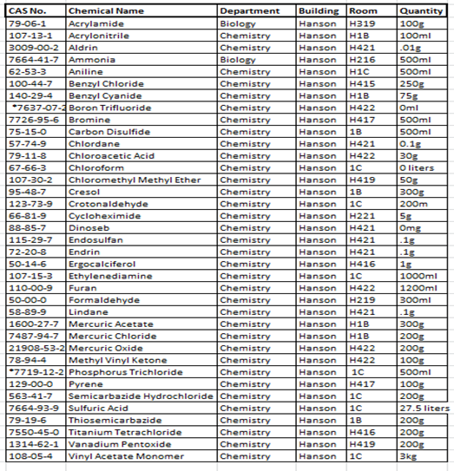
The above list is not a complete list of chemicals stored on campus, rather the most hazardous. For a complete list of chemicals please visit the online SDS page. https://augustana.net/offices/safety/MSDS/

